Steven Wheeler

www.newtontrailers.com
Newton Trailers Ltd
Station Yard, Station Road
Ridgmont
Bedfordshire
MK43 0XP
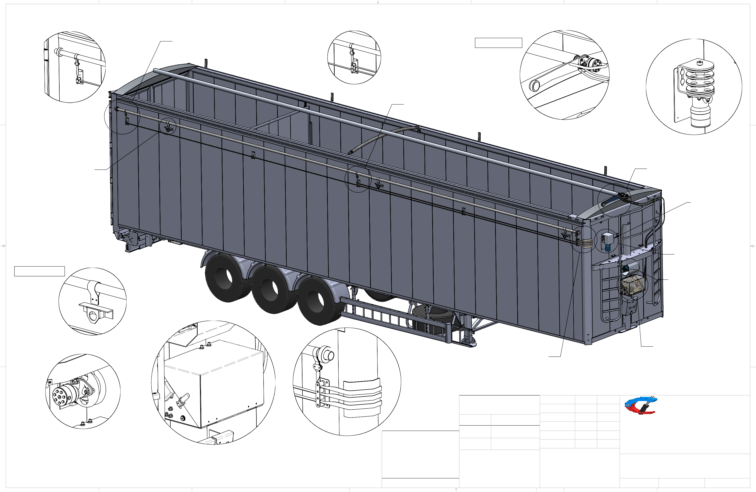

Newton Trailers
INSTALLATION & OPERATION MANUAL, MOVING FLOOR
Table of Contents
Introduction 3
Warranty 4
Safety 5
Tools Required 2
Fasteners 2
Kit contents 3
System Layout 4
Fitting 5
Power Pack 5
Side Motor 7
Hose Fitting 8
Hose Fitting (continued) 9
Strap Guide Plates 10
Strap Guide Plates (continued) 11
Strap Guides 12
Wear Plates 13
Front pillar 13
Front dome 13
Rear dome 14
Centre hoop position 14
SK-CPDA 15
Strap Fitting 17
Front position 17
Middle position 17
Rear position 17
Pole roller fastening 17
Bolting the straps to the pulley 18
Strap clamping 19
Storm straps 20
Storm strap eye 20
Fitting the storm strap anchor 21
Fixing the storm strap ratchet 21
Securing the sheet poles 22
Centre pole 22
Side pole 22
Final system checks 23
Trouble shooting 24
Hydraulic system layout 25
Sheet remote control system layout 26
Manual override PL20s 27
Manual override operation PL20s 28

Introduction
This manual explains procedures for installing and operating the Newton Trailers Auto sheet system Moving floor. Many variables affect the installation, but the general process remains consistent. Details of the installation can vary according to trailer features and installer preferences.
It is strongly recommended that installers and operators read this manual in its entirety before beginning the installation or operation of the system.

WARNING: Always disconnect electrical power to the trailer before entering the trailer or working on any of the Auto sheet system components. Failure to do so may result in serious injury or death due to the voltage involved in the sheeting system.

IMPORTANT: Installing the Auto sheet system requires some alterations to your trailer. Changes made without approval from the trailer manufacturer may void trailers warranty.

Warranty

This Auto sheet system is warranted to the original purchaser to be free from defects in material and workmanship under normal use for a period of one year from the date of purchase. During the warranty period, and upon proof of
purchase, the Auto sheet System will be repaired or replaced with the same or similar model.
IT IS EXPRESSLY AGREED THAT THIS SHALL BE THE SOLE AND EXCLUSIVE REMEDY OF THE BUYER. UNDER NO CIRCUMSTANCES SHALL Newton Trailers BE LIABLE FOR ANY C O S T S, LOSS, EXPENSE, DAMAGE, SPECIAL DAMAGES, INCIDENTAL DAMAGES, 0R CONSEQUENTIAL DAMAGES ARISING DIRECTLY OR INDIRECTLY FROM THE USE OF THE CLEAN SWEEP SYSTEM. WHETHER BASED UPON WARRANTY, CONTRACT NEGLIGENCE OR STRICT LIABILITY.
THE WARRANTY AND LIMITS OF LIABILITY CONTAINED HEREIN ARE IN PLACE OF ALL OTHER WARRANTIES AND LIABILITIES, EXPRESSED OR IMPLIED. ALL IMPLIED WARRANTIES OF MERCHANTABILITY AND FITNESS FOR A PARTICULAR PURPOSE HEREBY DISCLAIMED BY Newton Trailers AND EXCLUDED FROM THIS WARRANTY.
This warranty shall not apply to any parts that; (a} have been repaired or altered outside of the Auto sheet System; (b) have been subjected to misuse, negligence or accident; or (c) have been used or installed in a manner contrary to these Auto sheet System instructions.
In certain circumstances some states do not allow the exclusion or limitation of incidental damage, some or all the above limitations or exclusions may not apply to you. This warranty gives you specific legal rights, and you may have other rights that vary from country to country.
If this warranty violates law: To the extent any provision of this warranty contravenes the law of any jurisdiction, that provision shall be inapplicable in such jurisdiction and the remainder of the warranty shall not be affected thereby.
Notice: To validate all warranties, a proof of purchase with date and purchaser along with a brief write up of any faults with the items returned, must be supplied. Failure to do so will result in nonpayment and warranty items being scrapped.

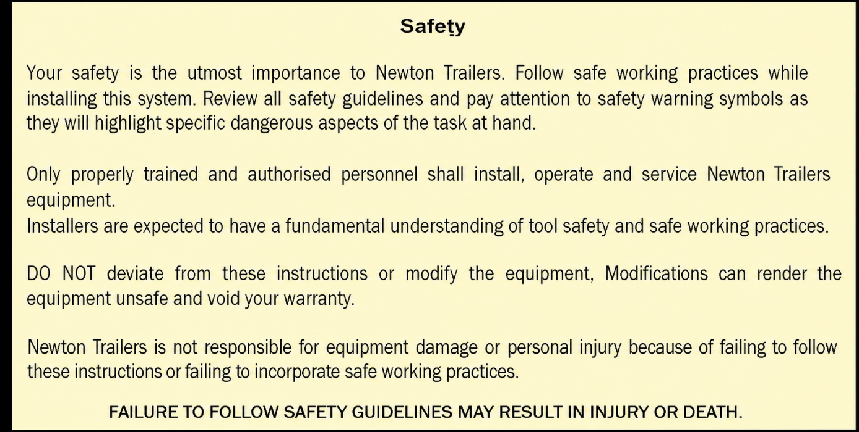Safety

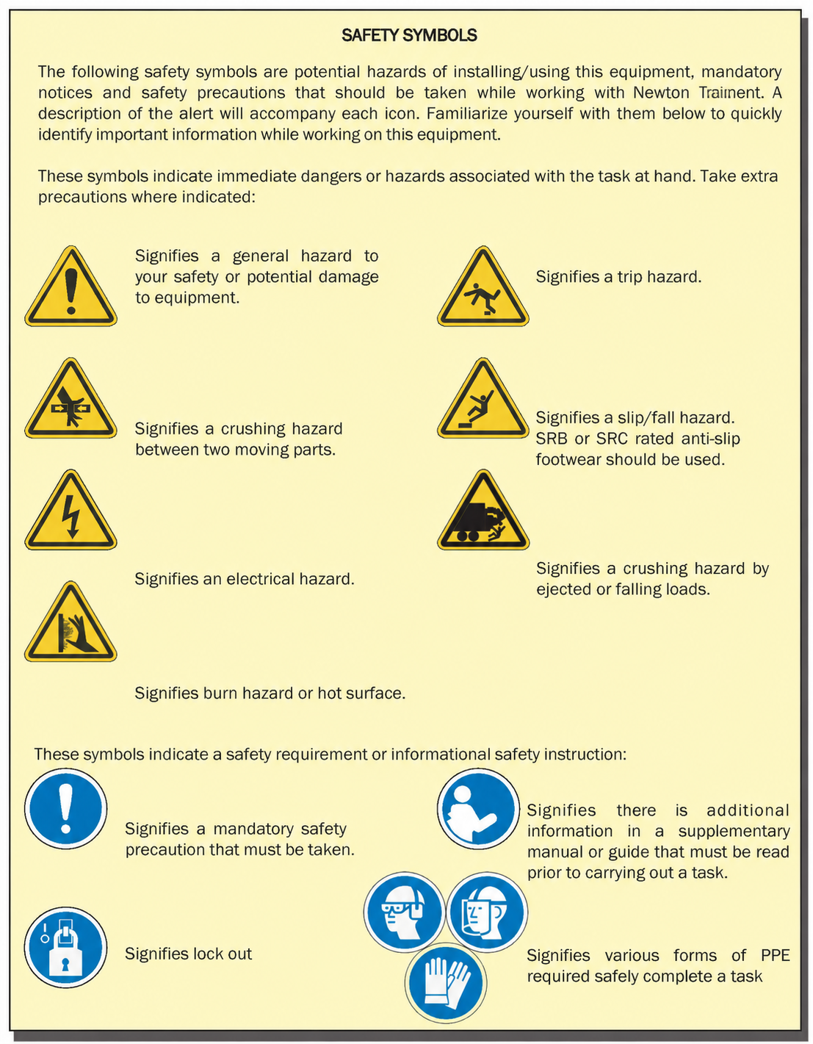

Tools Required

Metric socket set
Metric spanner set
Side cuts
Drill bits 4.8, 5, 6.8, 10, 12, 13 & 16mm
Drill taps 8 & 10mm
Rivet gun
Nut insert tool
Grinder where required
Tape measure
Hammer
Gas torch
Electrical crimps 25mm

Fasteners
It is recommended,

- Where possible to use stainless steel fasteners to reduce corrosion.
- Where possible use hex button socket bolts.
- Copper grease must be used to prevent pick up on bolt threads.
- Copper grease must be used to prevent thread pick up on drill bits & taps used.

Kit contents

Part No. | Description | Quantity
N1011350 | 24Vdc HPU ASSEMBLY | 1
N1011352 | STRAP MOTOR ASSEMBLY | 1
N1011351 | TOP MOTOR ASSEMBLY | 1
N1009246 | SHEET POLE STOP | 3
N1002258 | 1 PORT STRAP RUNNER | 3
N1002257 | 2 PORT STRAP RUNNER | 2
N1008076 | 3 PORT STRAP RUNNER | 1
N1006322 | MF SHEET STRAP SET | 1
N1000474 | STRAP CLAMPS | 3
N1005503 | NYLON WEAR STRIP | 2
N1000468 | COILED ANDERSON LEAD | 1
N1000469 | ANDERSON LEAD KIT | 1
N1011526 | TOP HOSE BRACKET | 1
Misc | HYDRAULIC ADAPTOR KIT | 1
N1011518 | TOGGLE SWITCH PLATE | 1
HC-SRP | STRAP RUNNER PLATE | 5
HC-MMP | MF MOTOR MOUNT PLATE | 2
HC-FRWP | FRONT & REAR WEAR PLATE | 2
HC-FWP | FRONT PILLAR WEAR PLATE | 1
HC-MFWPC | TIP WEAR PLATE CENTRE | 1
N1006449 | STORM STRAP RATCHET | 2
N1001081 | STORM STRAP GUIDE | 2
N1009219 | STORM STRAP ANCHOR | 2
N1002673 | STORM STRAP EYE | 2
N1003350 | STORM STRAP 3.82M | 2

System Layout

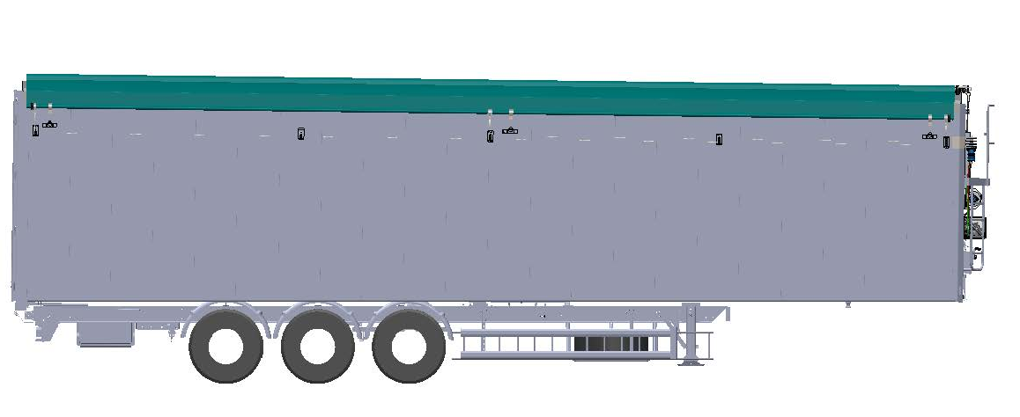

Fitting

N1011350
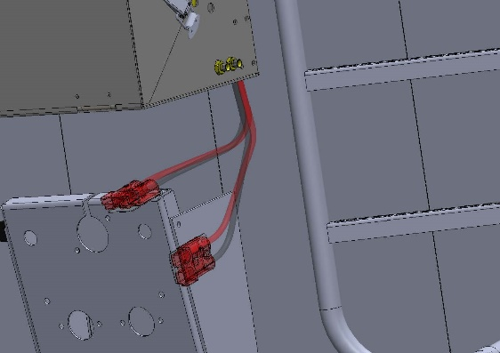
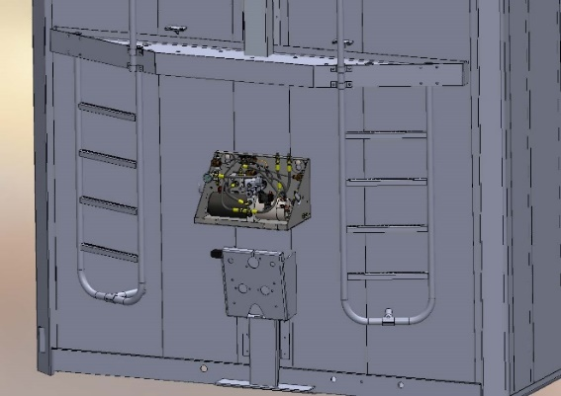
Step 1: Mount the powerpack box (see fig 1a), use the rear of the powerpack box as a template and mark 4 holes and drill to 12mm, fit M12 coach bolts and fix the nut on the bolt and slot the powerpack over the head of the bolts into the slots, hang the box and tighten the locking nuts (torque to fastener manufacturers spec) (plate the inner wall of the extruded material to prevent crushing).
Fig 1b
Fig 1a

Step 2: Routing the Anderson lead connection (see fig 1b), When the plug mounting position has been chosen, use the Anderson Plug as a template to mark the holes in the nose box bracket, drill using a 6mm bit. Fix using M6x50 bolts and locking nuts (torque to fastener manufacturers spec).
Step 3: Fitting the Anderson Sheet Kit, measure the length of battery cable required and cut off the excess, Strip, crimp/solder the pins for the Anderson plug end, add the Anderson boot and thread through the conduit. Crimp/solder the 0-008 8mm ring eyes for the powerpack.
Step 6: Route the Anderson cable into the box and fix the plug to the Anderson Plug using M6x50 cap head bolts and locking nuts and fasten the ring eyes to the powerpack (torque to fastener manufacturers spec).
Step 7: Secure the Anderson Sheet Kit to the bulkhead using 28mm P-clips & 4.8x25mm self-drilling torx screws equally spaced.

Step 8: Fitting the manual override for the sheet, this can be fitted to customer preference but must be in reach of the driver without both feet leaving the ground (Icarus Toggle Plate N1011518 can be used), Fix using M5x25MM bolts with locking nuts (torque to fastener manufacturers spec) (See fig 1c as an example).
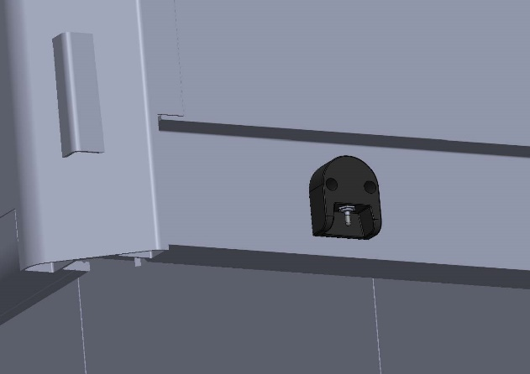

Fig 1c

N1011352
Step 1: Mount the brake motor mounting plate using 4.8 x 25mm self-drilling torx screws, the following measurements are from the top left-hand side. 390mm down from upper bulkhead weld and 480 in from the weld on the right hand-hand side, (see fig 2a below) (torque to fastener manufacturers spec), (plate the inner wall of the extruded material with a second plate to prevent crushing) (see fig 2b).
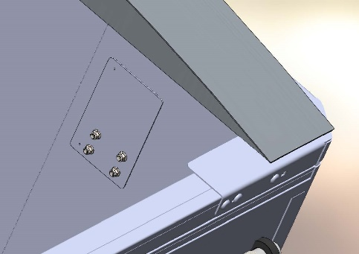
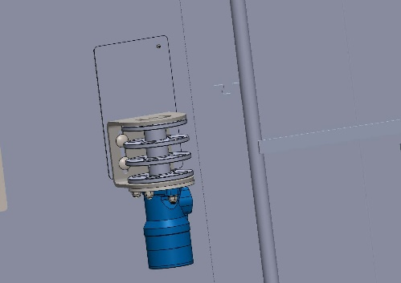 Fig 2a
Fig 2b
Step 2: Mounting the Motor Bracket to the plate (see fig 2a), drill 4 holes to 12mm, fix using M12x70mm coach bolts with locking nuts (torque to fastener manufacturers spec).
Step 3: Fit the 3 Strap Pulley (N1007576) to the motor, Fix the pulley using M8x70.
NOTE: Lubricate the motor shaft with Vaseline to prevent future corrosion, to make future servicing easy, nip the pulley retaining bolt by hand.
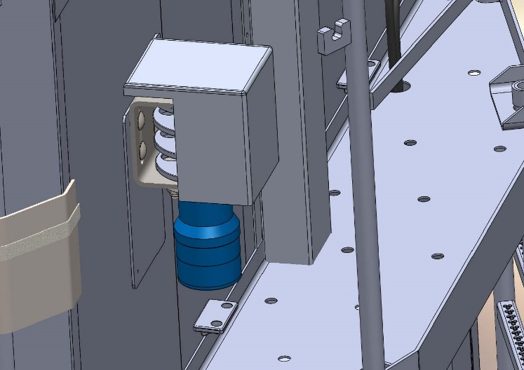
STEP 4: Fitting the pulley cover, pre-drill 2 holes in the Pulley Cover to 8mm and fit over the pulley, the bottom of the pulley cover must be flush with the underside of the brake motor bracket, mark the pre-drilled hole and drill tap to 8mm, M8x30 buttons to be used (the pulley can then be fit after testing) (see fig 2c).
Fig 2c

Hose Fitting

SK-SMA
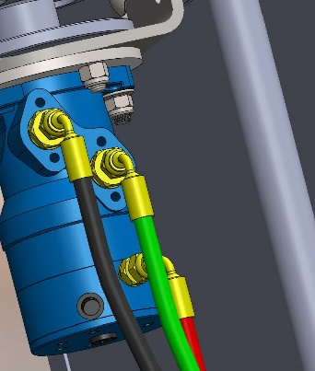
Step 1: Fit the ½ x ¼ fittings and bonded washers from the N1007495 strap motor (ZBMR) in the top 2 ports, fit the ¼ x ¼ and bonded washer to the upper port (see fig 3a).
Fig 3a

Step 2: Route the hoses from the powerpack box to the strap motor (see fig 3b).
Black = Pressure
Green = Return
Red = Pilot (brake)
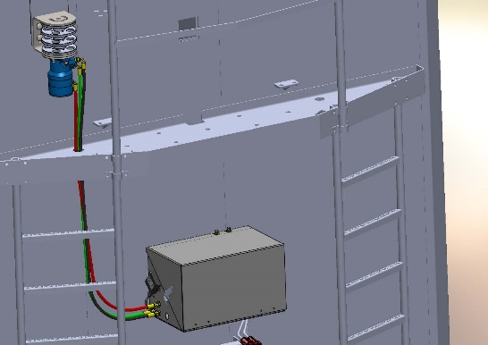

Fig 3b

Step 3: Secure the hoses to the bulkhead 19mm p-clips and 4.8x25mm self-drilling torx screws.
Step 4: Fit the top motor hose bracket N1011526 offer up to the position as in fig 3c, mark the mounting holes and drill tap to 8mm, fix using M8x30 buttons.

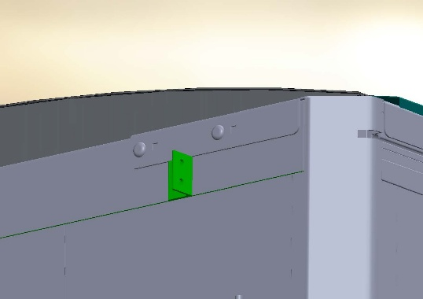
Hose Fitting (continued)

N1007263
Fig 3c

Step 5: Fit the ¼ bulkhead with nut to the N1011526 from the Adapter Kit (torque to fastener manufacturers spec).
Step 6: Route the hoses from the powerpack box to the hose top hose bracket (see fig 3d).
Black = Return
Red = Pressure
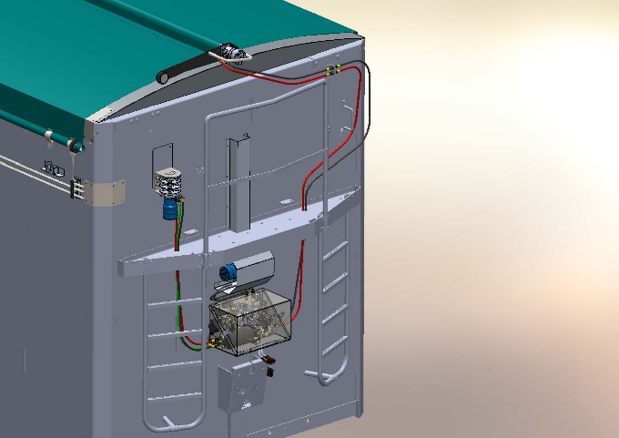
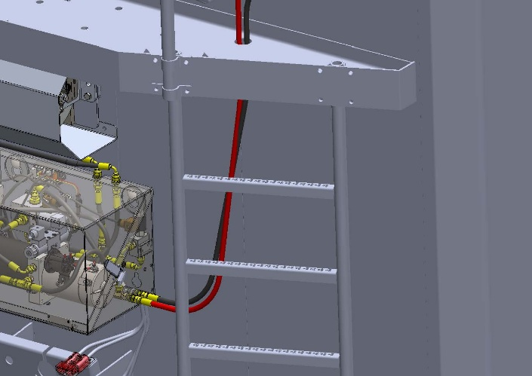
Fig 3d

Step 7: Hang the hoses for the top motor N1007263 (BMR), leave them loose until the top motor assembly is fitted into the centre pole.

Strap Guide Plates
Fitting strap mounting plates HC-SRP. Use the measurements from the pulley, transfer these to the sidewall for fitting the strap mounting plates (see fig 4a).
Fig 4a
Step 1: Front strap guide plate must be positioned so that the strap runs across the dome, mark the 4 outer holes in. Drill the marked holes to 11.5mm through the outer skin of the sidewall and fix in each hole an 8mm nut-sert, fix to the sidewall using M8x30 button bolts, 4 per plate (see fig 4b) (torque to fastener manufacturers spec).
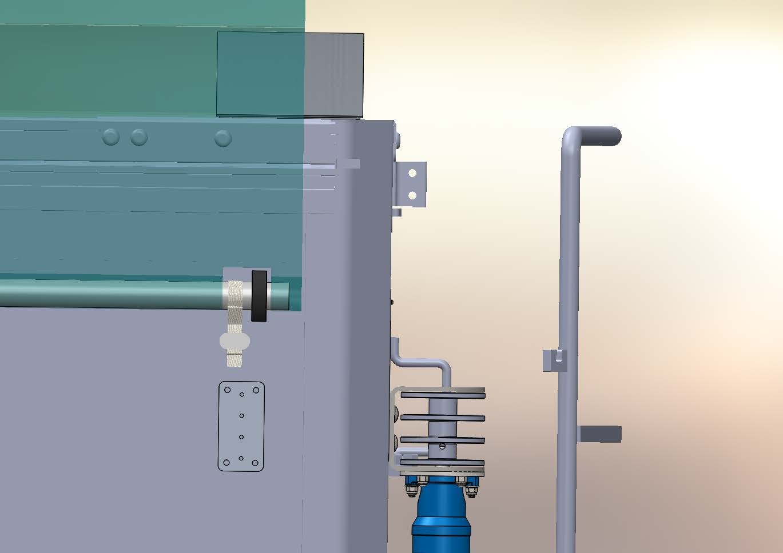
Fig 4b
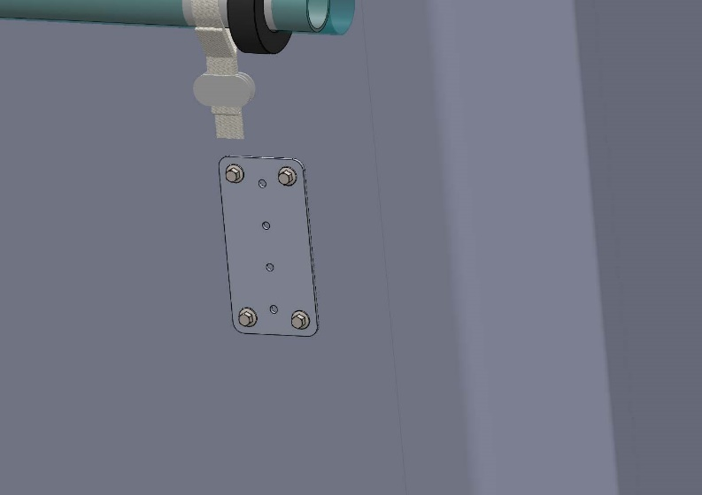
Step 2: Fit the middle and rear strap guide plates following the measurements and fixing procedure from Step 1.
NOTE: The middle strap guide plate must be fitted so that when the strap is fitted it runs between the centre hoops. For the rear the plate must be fitted so that the strap runs across the dome (see fig 4c-d).

HC-SRP (continued)

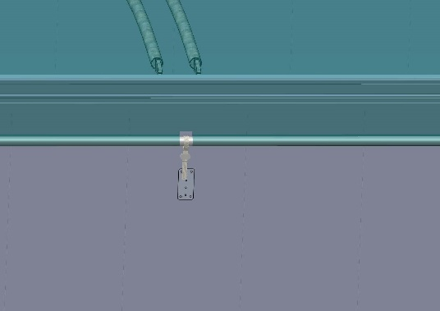
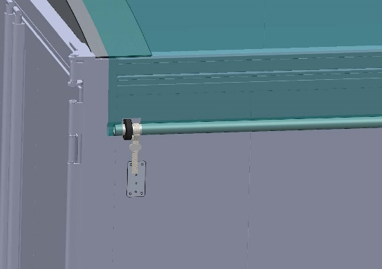 Fig 4c
Fig 4d

Step 3: Intermediate strap guide plates for front & rear sections. These need to be halfway between the 3 positions already fitted (see fig 4e-f), repeat measurements and fixing procedure from the previous steps.
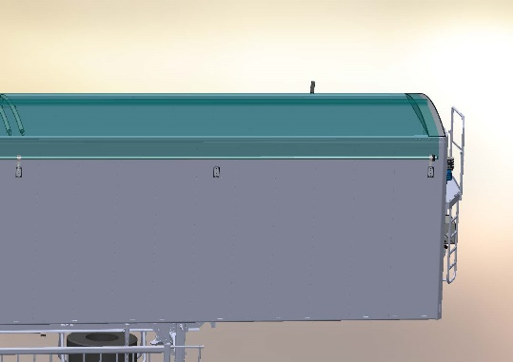
Fig 4e

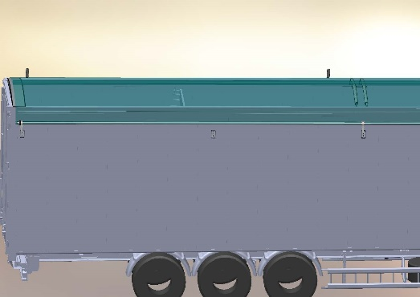

Fig 4f

Strap Guides

Drill through the central line of vertical holes in strap guide plate through the outer skin of the body in the appropriate hole for the strap guide position using an M8 drill tap.
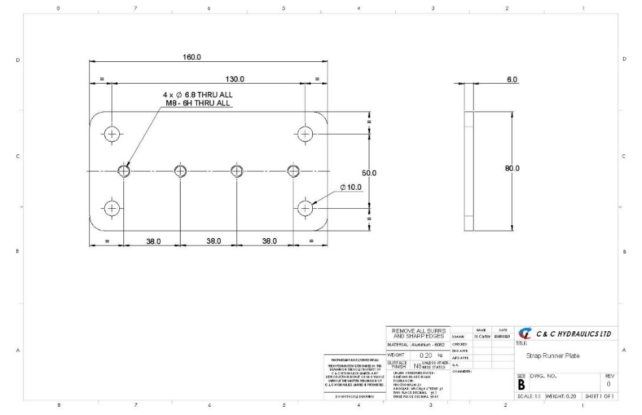
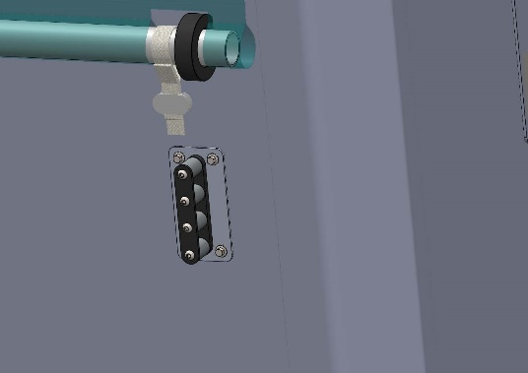
Step 1: Front strap guide position N1008076, Drill tap through all 4 holes and fix the strap guide using M8x70 buttons (see fig 5a).
Fig 5a

Fig 5b

Step 2: follow the procedure from Step 1 and continue for all remaining strap guides.
1st intermediate – drill tap top 2 holes.
Middle – top 3 holes.
2nd intermediate - middle two holes.
Rear – Bottom two holes.

This is so that the straps run in line and is more aesthetically pleasing on the eye.

Wear Plates

Note: If dome wear strips are to be fitted, lay out the nylon strips on the domes and drill 5mm holes through the nylon and the dome, equal spacing 300mm apart length ways and across the width. Fasten using 4.8mm large flange rivets.

Front pillar
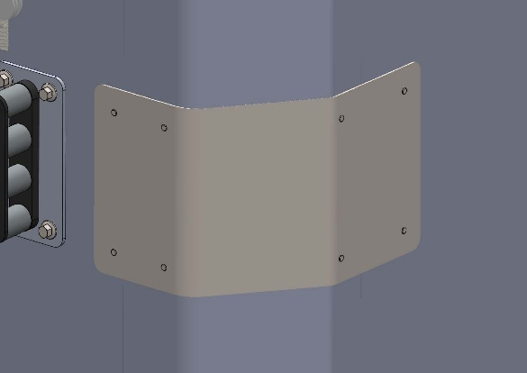
The front corner wear plate mounting holes are equal so can be mounted any way around if this is still fixed horizontally. Fix using 4.8mm large flange rivets. (see fig 6a)
Fig 6a

Front dome
The orientation of the plates must be noted, the side of the plate with 5 holes fixes to the body, the bottom of the plate should be flush with the bottom of the top rail profile. Offer up the wear plate as above and mark the line to be folded.
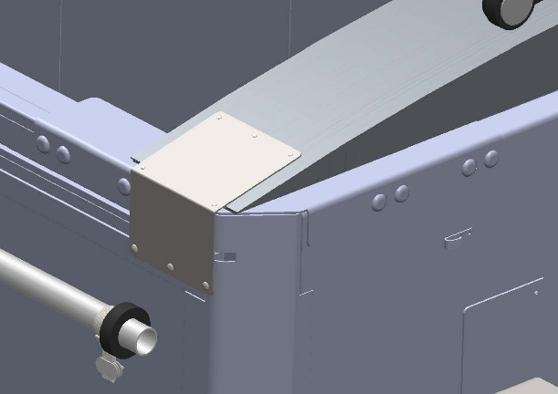
Attach the plate with 4.8mm large flange rivets on the side and 6.8 mono bolts on the top. (see fig 6b)
Fig 6b

Rear dome
Repeat the process as above. (see fig 6c)
Fig 6c
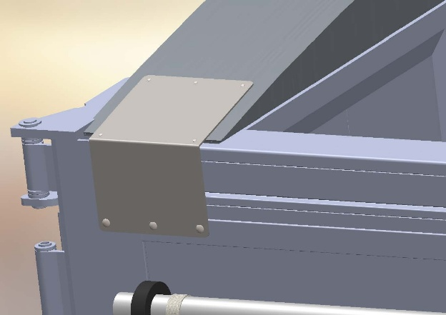

Centre hoop position
When the double hoop is fitted (as in the picture above) the process is repeated as with the front & rear wear plates. Apart from the horizontal plane. Fix using 6.8mm mono-bolts and shape the wear plate around the hoops with a hammer to eliminate and contact with the sheet. (see fig 6d)
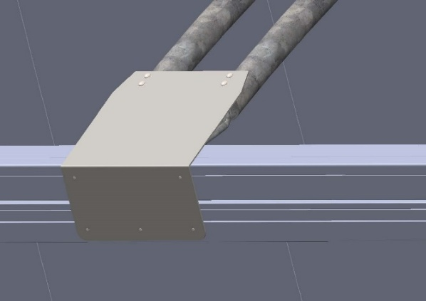
Fig 6d

NOTE: To reduce any contact between the sheet and centre hoops on the nearside a HC-WEARSTRIP may be required, this can be fastened into the centre hoops using 4.8mm large flange rivets.

SK-CPDA

Note: The fitting of the top motor can be done if the sheet & poles are being fit as new, sheet fitting manual is a separate document.

Roll the sheet all the way over to the closed position to carry out the next steps.

Step 1: Fitting the top motor assembly, start by inserting the nylon sleeve into the centre sheet pole, Insert the remainder of the assembly into the nylon sleeve leaving the tarp tube drive sticking out of the nylon sleeve by approx. 5mm. (see fig 7a)
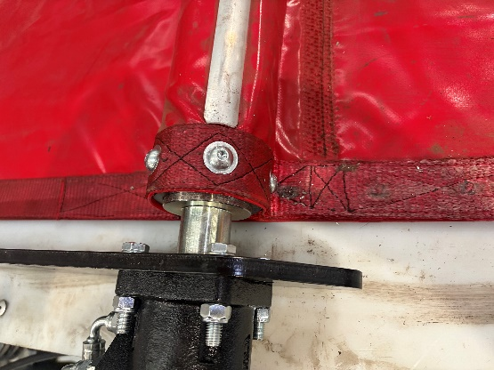

Fig 7a

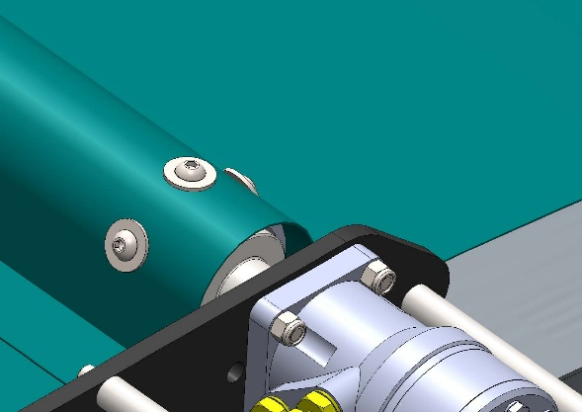
Step 2: (Option A) Using a 10mm bolt and a pair of mole grips clamped on the bolt head heat up the bolt thread until glowing and burn through the sheet reinforcement webbing in 3 positions (see picture below), Using those 3 positions as reference drill-tap to 10mm through the pole and tarp tube drive. Fix using M10x30 button hex bolts & repair washers (torque to fastener manufacturers spec). (see fig 7b)
Fig 7b

Step 3: (Option B) Using an 8mm bolt repeat the process above but drill through the pole and tarp tube drive to 6.8mm and fix using 6.8x25mm Mono-bolts and repair washers.

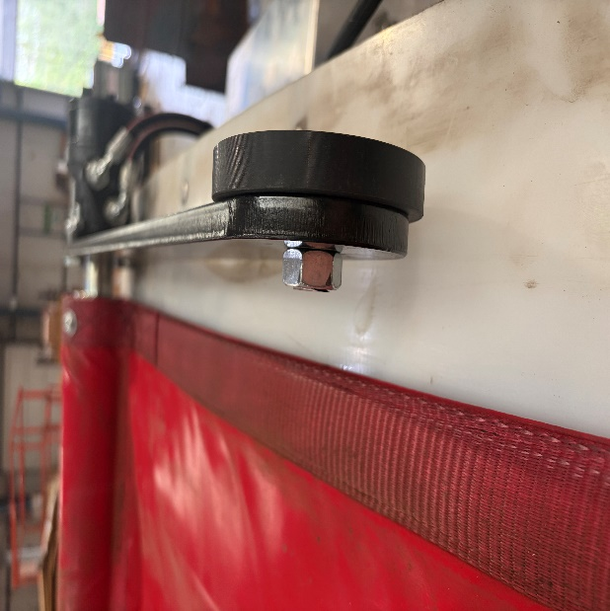

Step 4: Fit the top motor hoses to the motor and N1011526 bracket, Top port on the bracket to top port on the motor and bottom to bottom port.

Adaptors required:
½” x ¼” M/M x2
½” bonded seals x2

Strap Fitting

Front position
Step 1: Offer up the strap to the side pole at 90 degrees, mark the pocket to be cut before cutting out with a Stanley knife. If pole rollers are to be fit, elongate the pocket to be cut out.
Step 2: If a pole roller is to be fit slide the side sheet pole to the rear, insert the pole roller into the pocket and slide the pole back making sure the pole roller slides freely over the side pole.
Step 3: Using the blow torch, burn off any loose stitching post pocket cutting.

Middle position
Repeat step 1 as above, pole rollers are not fitted to the middle of the trailer.

Rear position
Repeat step 1 as the front position and step 2 if a pole roller is to be fitted.

Pole roller fastening
If pole rollers are to be fitted, follow the next step.
Mark either side of the pole roller, ensuring the roller runs across the domes. Using the M8 drill-tap drill, drill through to the centre of the pole and fasten using M8x16 button headed bolts (torque to fastener manufacturers spec).
Repeat for the rear pole roller.
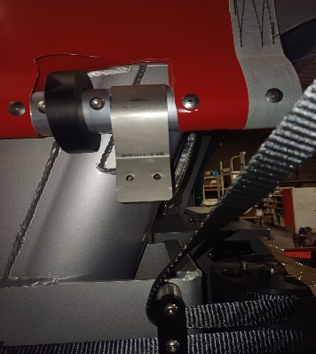

Pole rollers are fit to reduce the side pole encountering the body, when no pole roller is fit to the side pole, the sheet strap encounters the side of the body and dome increasing wear on both the sheet and strap. The most common place a sheet strap breaks is on the rear of the pole when the strap is clamped.
When the pole rollers are coupled with the alu torque arm with roller this reduces wear on the sheet and straps and removes the need for the nylon dome wear strips HC-DWS.

Bolting the straps to the pulley
Step 1: Thread the 16’ front strap from N1006322 strap kit through the first strap guide.
Step 2: Insert the eye of the short strap into the top recess of the pulley and slide in the M6x110 Cap head bolt to retain the front strap.
Note: Cover the strap retaining bolt threads with Vaseline to prevent corrosion.
Step 3: Thread the longer 38’ section of N1006322 strap kit through the strap guides from the front to the middle strap guide, insert the bolt through the strap eye at the pulley end.
Step 4: Thread the remaining 60’ strap through the strap guides from the front to the rearmost strap guide, dropping the bolt through the strap eye.
Step 5: Thread the bolt through the strap eye and into the thread of the pulley, tighten finger tight only. This makes future strap replacement easier.
Note: It is important to make sure all straps are not twisted or tangled.
Step 6: Wrap the straps around the pulley clockwise so that when the strap is unwinding it runs anticlockwise and releases from the spool to the outside of the body.
Step 7: Spray the (N1007495) ZBMR brake motor shaft with copper grease. Fit the pulley to the ZBMR brake motor and fasten with an M8x70 bolt with a spring and flat washer, tighten using a hand ratchet and nip the bolt.
Note: Do not over tighten as this will make strap replacement and splitting the pulley from the motor easier.

Strap clamping (N1000474)

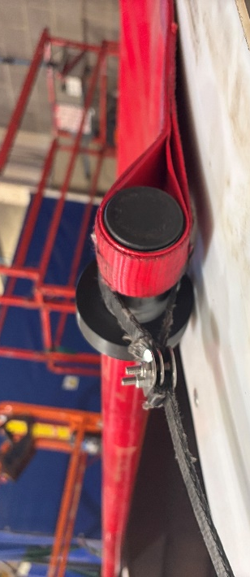
Step 1: Wrap the strap around the pole from the rear and fit the strap clamp with the studs facing away from the body as in the above image. Pull the strap tight and fit the first clamp plate, run the strap back up over the outer side of the plate and fit another plate over the top and fit the locking nuts (torque to fastener manufacturers spec). (see fig 8a)
Fig 8a

Note: Never over tighten as the studs can spin where they are spot welded to the rear plate and the threads can strip; it is recommended that a hand ratchet be used for these.

Step 2: Cut the strap to length, burn of the end to prevent fraying.

Step 3: Cable tie the cut off end to the bottom side of the strap clamp and cut the tail of the cable tie flush.

Repeat for all steps for all 3 strap positions.

Storm straps
Note: If storm straps are not required skip this section.

Storm strap eye (HC-SSE)
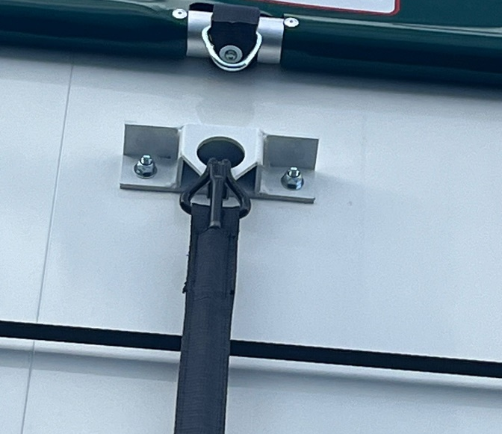
Step 1: Mark the desired position on the side pole for a pocket to be cut for N1002673 (bearing in mind the side wall construction). Cut the sheet and burn off and threads remaining.

Step 2: Wrap the storm strap eye around the pole from the rear so the eye is hanging away from the body, temporarily secure the storm strap eye in position with duct tape.

Step 3: heat up a 10mm bolt with the blow torch until glowing and burn a hole through the strap either on the underside of the pole or outer edge.

Step 4: Once the molten webbing has cooled, drill tap an 8mm hole through to the centre of the pole and secure using an M8x30 button headed bolt & repair washer (torque to fastener manufacturers spec).
Note: Alternatively, this can be drilled to 6.8mm and a mono-bolt with washer can be used.

Fitting the storm strap anchor (HC-SIDE POLE ANCHOR)
Step 1: Offer the storm strap anchor 100mm below the storm strap eye (bearing in mind the side wall construction).

Step 2: Drill through the body with a 10mm drill bit using M10x50 bolts with locking nuts, repair washers or a backing plate may be required to prevent crushing, (torque to fastener manufacturers spec).

Step 3: Hang the storm strap from the anchor to line up for the N1001081 fitting. Place the storm strap guide on the bottom rail of the body, mark the mounting holes and drill to 5mm, fix using 4.8mm rivets.

Fixing the storm strap ratchet

Step 1: Finding the desired position for the N1006449 , position the storm strap ratchet in the desired position and mark a hole to secure the ratchet. Drill to either 8 or 10mm and secure with bolts & locking nuts.

Note: If the ratchet is binding in the mounting position, pack out between the body and the ratchet with washers or weld a cut section of 50x75mm Alu or Steel box section.

Step 2: Cut the storm strap tail to length with a diagonal cut and burn off the tail to prevent fraying.

Step 3: Lubricate the ratchet.

Note: Cutting the strap tail diagonally aids threading the strap into the ratchet.

Securing the sheet poles
If the centre pole has been secure in the sheet fitting section (separate manual) then miss this next section.

Centre pole
Step 1: Using half round 25mm beading cut four pieces into 350mm lengths and lay out on the top of the sheet pole, measurements are variable as long as its equal distances. First position can be 100mm from the webbing strip sewn into the sheet, mirrored on the rear then either side of the centre hoop for the middle.

Step 2: Drill x3 5mm holes in each strip 30mm in from each end one central, fasten using 4.8 x 25mm large flange rivets.

Step 3: Drill to 5mm and rivet the webbing strip at the rear of the centre sheet pole and fasten with 4.8 x 25mm large flange rivets.

Side pole
Step 1: Marking the fixing points to secure the side pole in the pole pocket. Mark a point on the front sheet webbing strip, either side of the sheet strap pocket, middle either side of the strap pocket and rear either side of the strap pocket.

Step 2: Drill holes to 5mm and fix using 4.8mm x 25 large flange rivets.

Final system checks

Step 1: Fill the sheet pack with oil.
Note: It is recommended that ATF fluid be used to prevent bacterial growth clogging up the tank suction filter.
Step 2: Check all hydraulic fittings are tight with a spanner to prevent any oil leakage.
Step 3: Turn on the Icarus remote set and check power status, Pairing the remote system to the Icarus app can run firmware updates and check for any electrical issues.
Step 4: Check all persons are clear of the sheet before operating.
Step 5: Operate the sheeting system open and closed 4 or 5 times.
Step 6: Check for oil leaks.
Step 7: Top up oil if required.
Step 8: Check sheet straps for tightness and adjust if required.

Note: It is important that the oil level and all fixing and hoses be checked 1 week after system fitting and that the sheeting system must be inspected upon the date over every vehicle inspection.
Max sheet pack operating pressure 150 Bar when sheet hits the sheet stops or the limit when closing.
Optimum pressure with Aluminium torque arm and side pole rollers the sheet system pressure runs at 50 bar, when the sheet hits the apex of the dome the pressure will spike to 90 Bar.
ZBMR brake pilot pressure to release 25 BAR.

Never:
Under any circumstance must the pressure relief valve be adjusted, this is preset at 150 Bar, Increasing the pressure relief can burst motor seals, split the roof sheet and pull the sheet strap clamps loose.

Trouble shooting

- If the Icarus remote turns on but does not pair, Check the status light on the receiver.
- No status light on the receiver? Check power to the sheet pack starter using a test lamp or multi meter.
- No power to starter motor? Check Anderson plug connections and power supply form source.
- Icarus remote paired to receiver but no output action? Pair the receiver to the Icarus app and check error codes and fix.
- No error codes from the Icarus system? Check output from the starter motor and replace if needed.
- Starter motor working but no movement in hydraulic system? Check pressure output on the pressure gauge.
- No pressure at the gauge? Check oil level.
- Starter motor working and pump starting no output? Check power to coils & test coils.
- Sheet motor struggling to open/close sheet? This indicates a weak motor.
Fit adaptor pressure gauge adaptor in pressure lines and check pressures to motors. Check the ZBMR pilot line for pressure to release the brake (refer to system checks for pressures).

Icarus operating and troubleshooting manual comes with the remote set, further digital copies available upon request.

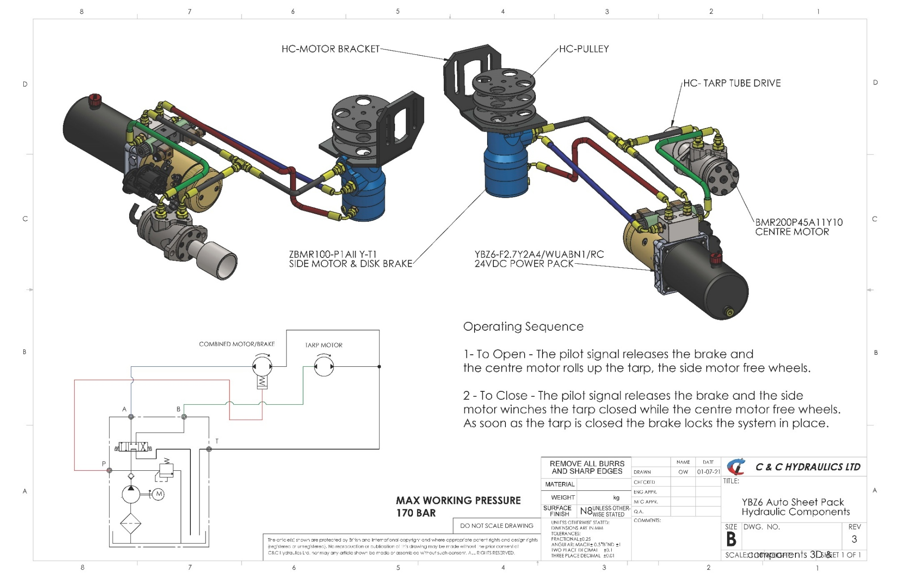
Hydraulic system layout

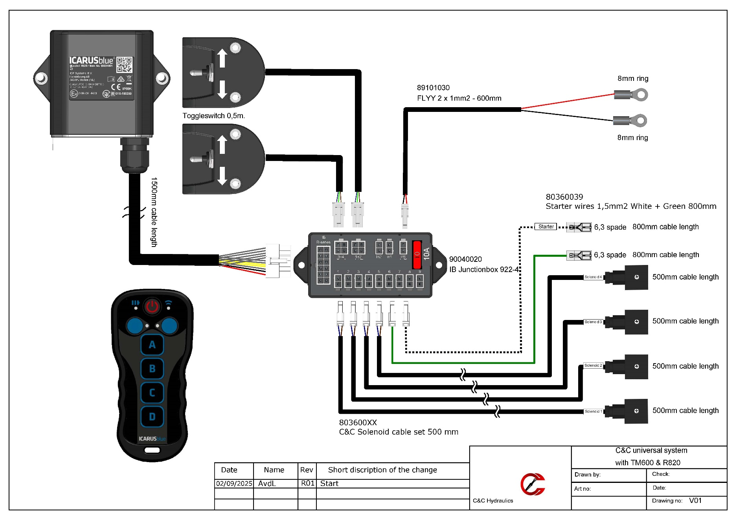
Sheet remote control system layout
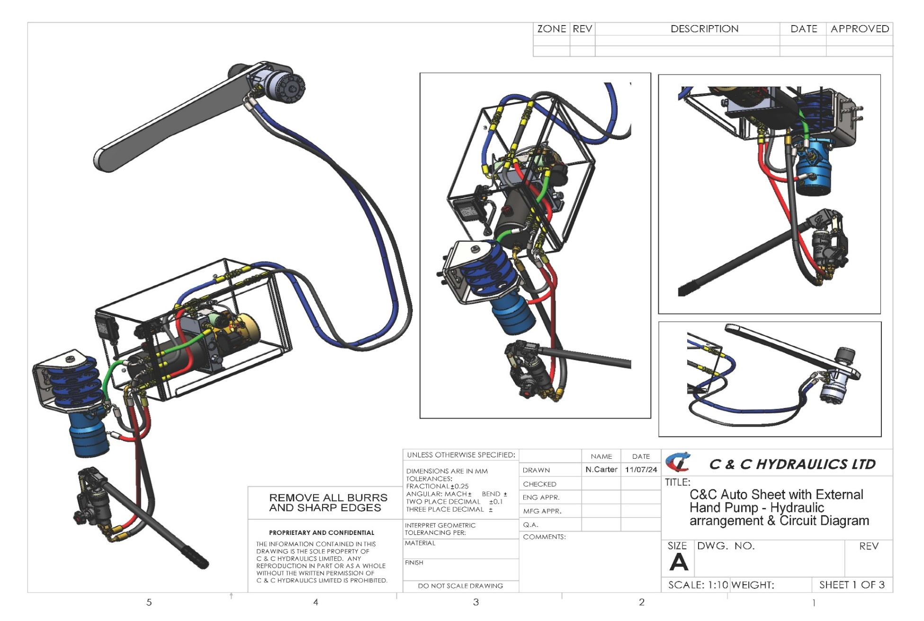
Manual override PL20s (option)

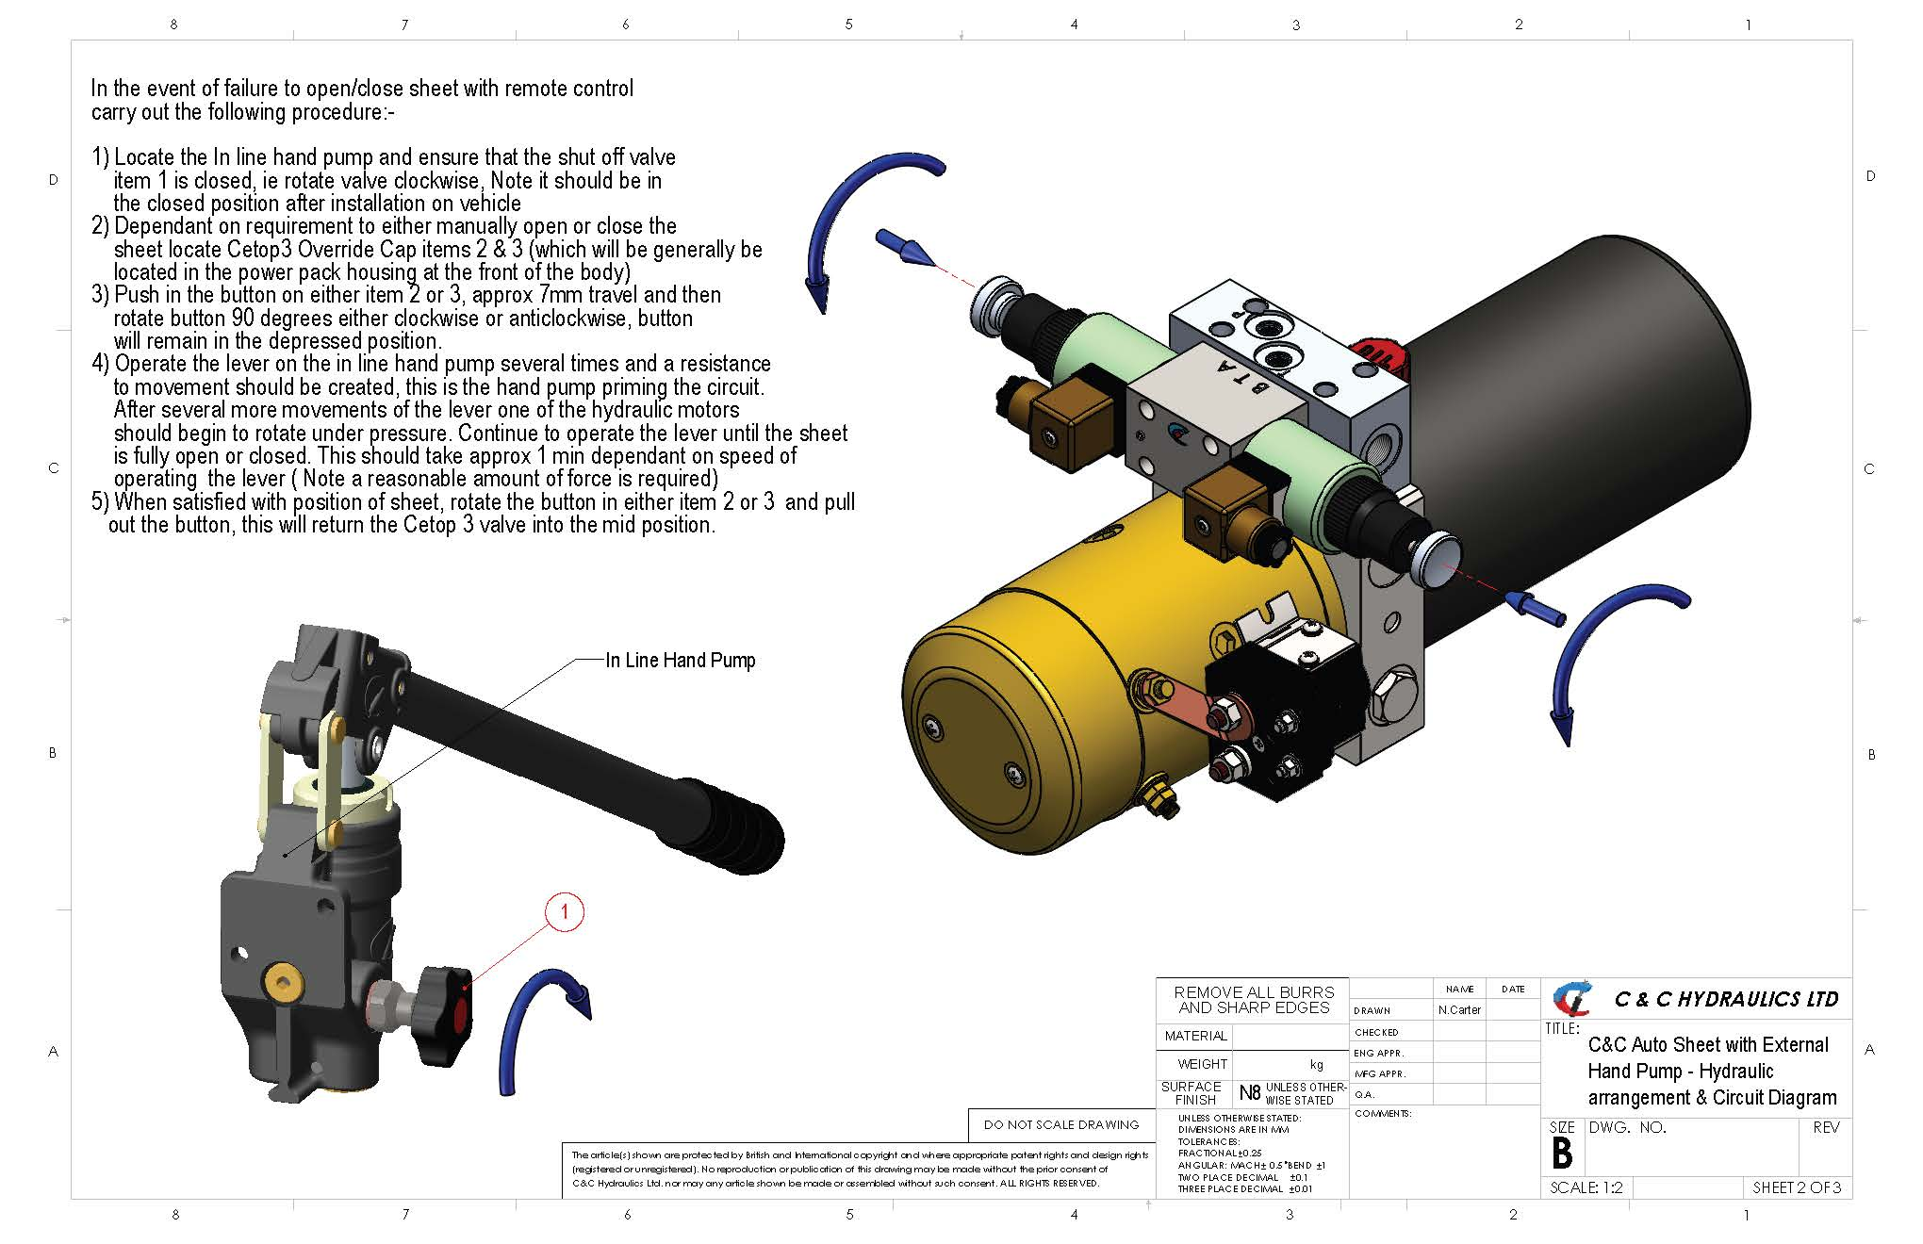
Manual override operation PL20s (option)



Newton Trailers Ltd
Station Yard
Station Road
Ridgmont
Bedfordshire
MK43 0XP
01525 872466
www.newtontrailers.com
sales@newtontrailers.com

