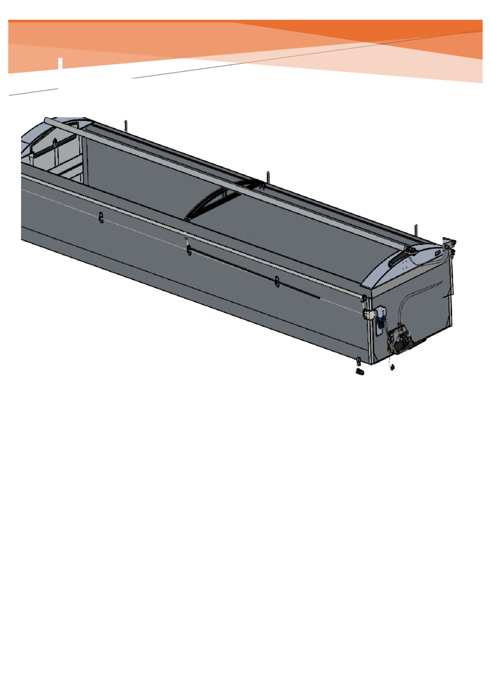
INSTALLATION & OPERATION MANUAL, TIPPER
Andy Brunskill
22/04/26
NEWTON TRAILERS AUTO SHEET
SYSTEM
www.newtontrailers.com
Newton Trailers Limited
Station Yard, Station Road
Ridgmont, Bedfordshire
MK43 0XP
01525 872466

Table of Contents
Introduction .................................................................................
Warranty ................................................................................................................ i4
Safety ..................................................................................................................... i5
Safety Icons………………………………………………………………….…………………………………i5
Fitting
Tools Required ......................................................................................................... 2
Fasteners ................................................................................................................ 2
Kit contents ............................................................................................................. 3
System Layout ......................................................................................................... 4
Wear Plates ............................................................................................................. 7
Hose Position .......................................................................................................... 8
Wiring ................................................................................................................... 10
Centre Motor ......................................................................................................... 12
Strap Fitting ........................................................................................................... 14
Front position ..................................................................................................... 14
Middle position................................................................................................... 14
Rear position ...................................................................................................... 14
Pole roller fastening ............................................................................................ 14
Bolting the straps to the pulley ............................................................................. 15
Fitting the pulley cover ........................................................................................ 16
Strap clamping ................................................................................................... 17
Storm straps ...................................................................................................... 18
Securing the sheet poles ..................................................................................... 20
Final system checks ............................................................................................... 21
Trouble shooting .................................................................................................... 22
Schematics ……………………………………………………………………………………………………23
Newton Trailers Limited

Introduction
It is strongly recommended that installers and operators read this manual in its entirety
before beginning the installation or operation of the system.
WARNING: Always disconnect electrical power to the trailer before entering the trailer or
working on any of the Auto sheet Tipper System components. Failure to do so may result
in serious injury or death due to the voltage involved in the sheeting system.
IMPORTANT: Installing the Auto sheet Tipper System requires some alterations to your
trailer. Changes made without approval from the trailer manufacturer may void trailers
warranty.
Newton Trailers Limited
This manual explains procedures for installing and operating the Newton Trailers Auto sheet Tipper
System. Many variables affect the installation, but the general process remains consistent. Details of
the installation can vary according to trailer features and installer preferences.

Warranty
This Auto sheet System is warranted to the original purchaser to be free from defects in
material and workmanship under normal use for a period of one year from the date of
purchase. During the warranty period, and upon proof of
purchase, the Auto sheet System will be repaired or replaced with the same or similar model.
This warranty shall not apply to any parts that; (a} have been repaired or altered
outside of the Auto sheet System; (b) have been subjected to misuse, negligence
or accident; or (c) have been used or installed in a manner contrary to these Auto
sheet System instructions.
In certain circumstances some states do not allow the exclusion or limitation of
incidental damage, some or all the above limitations or exclusions may not apply
to you. This warranty gives you specific legal rights, and you may have other rights
that vary from country to country.
If this warranty violates law: To the extent any provision of this warranty contravenes
the law of any jurisdiction, that provision shall be inapplicable in such jurisdiction
and the remainder of the warranty shall not be affected thereby.
Notice: To validate all warranties, a proof of purchase with date and purchaser along
with a brief write up of any faults with the items returned, must be supplied. Failure
to do so will result in nonpayment and warranty items being scrapped.
Newton Trailers Limited
IT IS EXPRESSLY AGREED THAT THIS SHALL BE THE SOLE AND EXCLUSIVE
REMEDY OF THE BUYER. UNDER NO CIRCUMSTANCES SHALL NEWTON TRAILERS BE
LIABLE FOR ANY COSTS, LOSS, EXPENSE, DAMAGE, SPECIAL DAMAGES,
INCIDENTAL DAMAGES, OR CONSEQUENTIAL DAMAGES ARISING
DIRECTLY OR INDIRECTLY FROM THE USE OF THE CLEAN SWEEP SYSTEM,
WHETHER BASED UPON WARRANTY, CONTRACT NEGLIGENCE OR STRICT LIABILITY.
THE WARRANTY AND LIMITS OF LIABILITY CONTAINED HEREIN ARE IN
PLACE OF ALL OTHER WARRANTIES AND LIABILITIES, EXPRESSED OR
IMPLIED. ALL IMPLIED WARRANTIES OF MERCHANTABILITY AND FITNESS
FOR A PARTICULAR PURPOSE ARE HEREBY DISCLAIMED BY NEWTON TRAILERS AND
EXCLUDED FROM THIS WARRANTY.

Safety

FAILURE TO FOLLOW SAFETY GUIDELINES MAY RESULT IN INJURY OR DEATH.
Newton Trailers Limited
Your safety is of the utmost importance to Newton Trailers. Follow safe working practices while installing this
system. Review all safety guidelines and pay attention to safety warning symbols as they will highlight specific
dangerous aspects of the task at hand.
Only properly trained and authorised personnel shall install, operate and service Newton Trailers equipment.
Installers are expected to have a fundamental understanding of tool safety and safe working practices.
DO NOT deviate from these instructions or modify the equipment. Modifications can render the equipment unsafe
and void your warranty.
Newton Trailers is not responsible for equipment damage or personal injury caused by failure to follow these
instructions or to incorporate safe working practices.
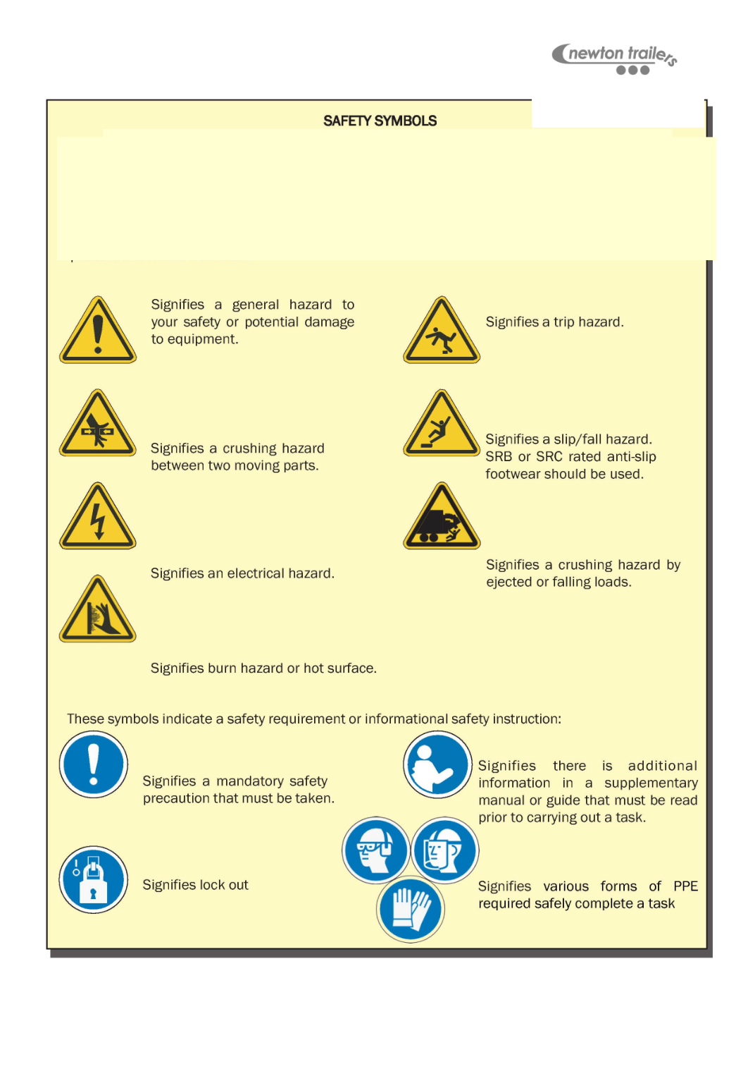
The following safety symbols are potential hazards of installing/using this equipment, mandatory
notices and safety precautions that should be taken while working with Newton Trailers equipment. A
description of the alert will accompany each icon. Familiarize yourself with them below to quickly
identify important information while working on this equipment.

Tools Required
Metric socket set
Metric spanner set
Side cuts
Drill bits 4.8, 5, 6.8, 10, 12, 13 & 16mm
Drill taps 8 & 10mm
Rivet gun
Nut insert tool
Grinder where required
Tape measure
Hammer
Gas torch
Electrical crimps 25mm
Fasteners
It is recommended,
• Where possible to use stainless steel fasteners to reduce corrosion.
• Where possible use hex button socket bolts.
• Copper grease must be used to prevent pick up on bolt threads.
• Copper grease must be used to prevent thread pick up on drill bits & taps used.
Newton Trailers Limited

Kit contents
Part No.
Description
Quantity
SK-PIAB
24Vdc HPU ASSEMBLY
1
SK-SMA
STRAP MOTOR ASSEMBLY
1
SK-CPDA-V2
TOP MOTOR ASSEMBLY
1
HC-POLESTOP
SHEET POLE STOP
3
HC-1PSG
1 PORT STRAP RUNNER
3
HC-2PSG
2 PORT STRAP RUNNER
2
SK-TIP2STRAP
TIPPER STRAP SET
2
HC-CLAMPASSYS
STRAP CLAMPS
3
HC-SIDEPOLEROLLER
NYLON POLE ROLLER
2
HC-BSL-A
COILED ANDERSON LEAD
1
BK-175A
ANDERSON PLUG
1
SK-TIPANDERSON
ANDERSON LEAD KIT
1
HC-APP
ANDERSON PLUG PLATE
1
HC-THB
TOP HOSE BRACKET
1
HK-ADKIT
HYDRAULIC ADAPTOR KIT
1
1/4BULKHEAD
¼ BULKHEAD FITTINGS
2
HK-STA
HYDRAULIC HOSE KIT
1
HC-TSP
TOGGLE SWITCH PLATE
1
HC-SRP
STRAP RUNNER PLATE
4
SK-STABK
STAS BOLT KIT
1
HC-FRWP
FRONT & REAR WEAR PLATE
2
HC-TIPWPC
TIP WEAR PLATE CENTRE
1
Newton Trailers Limited
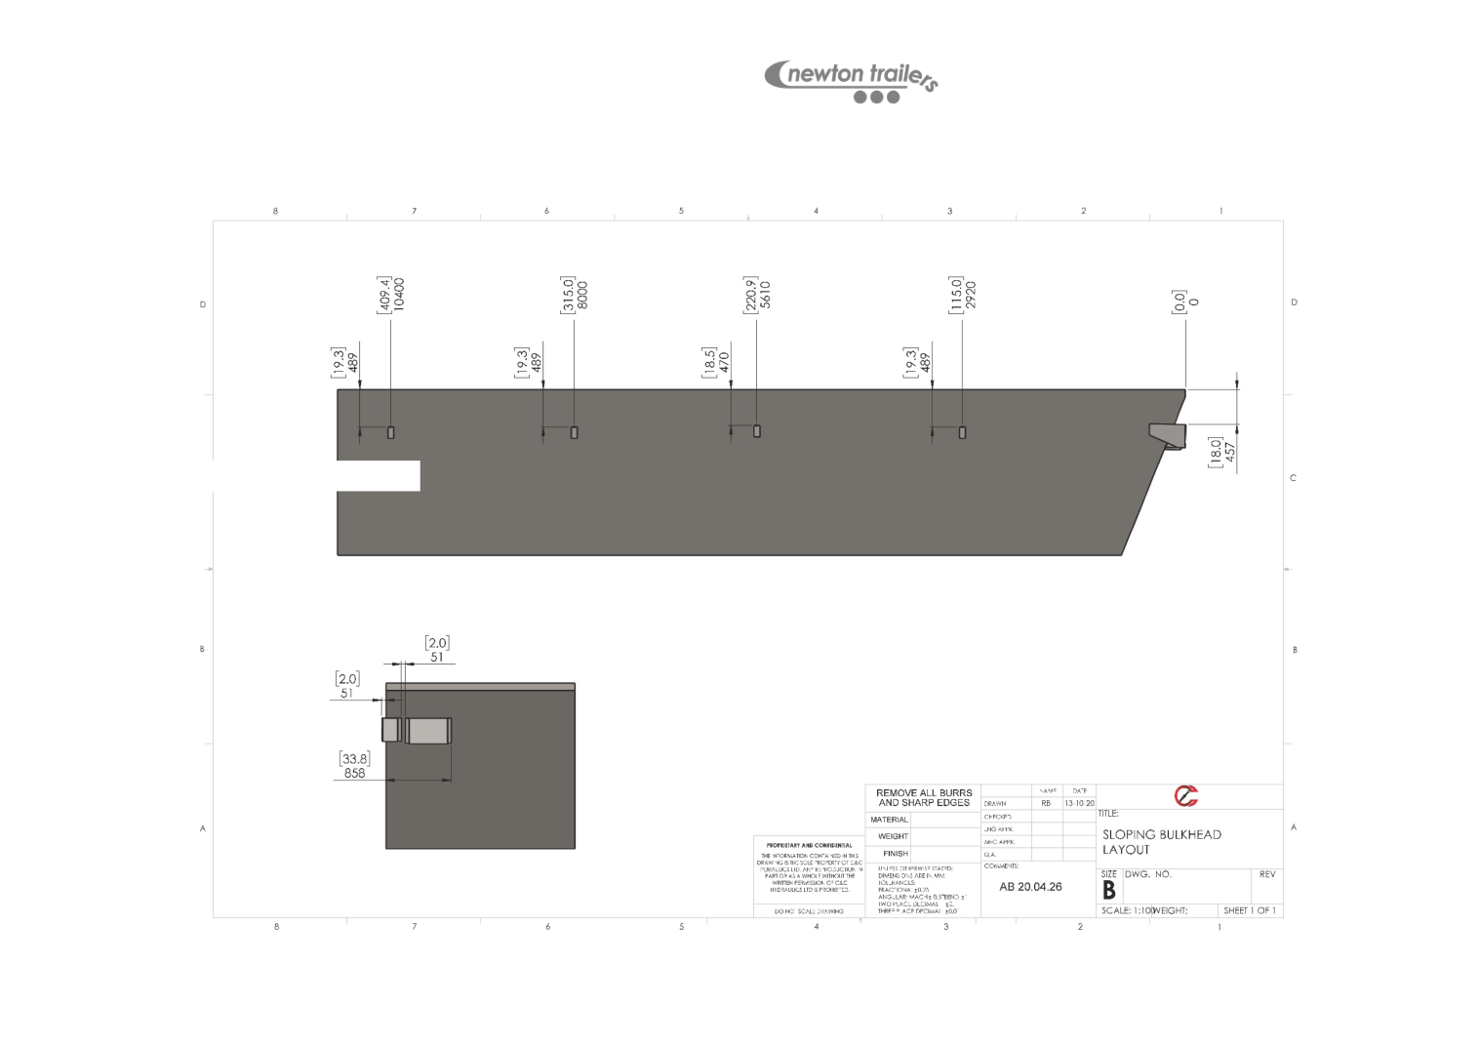
System Layout
Newton Trailers Limited

Step 1: Mount the powerpack box bracket, The most common mou
position of the powerpack box is at the top righthand side, 457mm d
uppermost point of the bulkhead, Fix using 10mm bolts with locking nuts (torque to
fastener manufacturers spec).
Step 2: Mount the brake motor backing plate assembly 457mm down from the upper
most point of the bulkhead ﬁx using 10mm bolts with locking nuts (torque to fastener
manufacturers spec), (plate the inner wall of the extruded material to prevent crushing),
Note: Box and motor bracket mounts not required for square bodies.
Step 3: Mount the powerpack box to the box bracket (if used), use the rear of the
powerpack box as a template and mark 4 holes and drill, ﬁt M12 coach bolts and ﬁx the
nut on the bolt and slot the powerpack over the head of the bolts into the slots, hang the
box and tighten the locking nuts (torque to fastener manufacturers spec).
Step 4: Mount the brake motor bracket to the Alu backing plate (if used) at the bottom
left-hand side, drill 4 holes centrally in the bolt slots to allow adjustment up and down,
ﬁx using M12 coach bolts with locking nuts (torque to fastener manufacturers spec).
Step 5: Mount the brake motor with M10x50 coach bolts and locking nuts (torque to
fastener manufacturers spec), Fit the pulley to the motor, to make future servicing easy
only tighten the pulley retaining bolt ﬁnger tight.
Step 6: Mount the ﬁrst 2 port strap guide using the pulley position as a template, bolt
through the Alu brake motor assembly using M8x70 bolts with locking nuts (torque to
fastener manufacturers spec).
Step 7: Fitting HC-SRP strap mounting plates to the sidewall. Using the strap mounting
plate as a template offer the plate to the body with the top of the plate 489mm down
from the top of the chop rail, mark the 4 outer holes in the 4 remaining strap guide
positions. Drill holes through the outer skin of the sidewall and ﬁx in each hole an 8mm
nut-sert, follow on for all strap positions and ﬁx to the sidewall using M8x30 button
bolts, 4 per plate (torque to fastener manufacturers spec).
Newton Trailers Limited
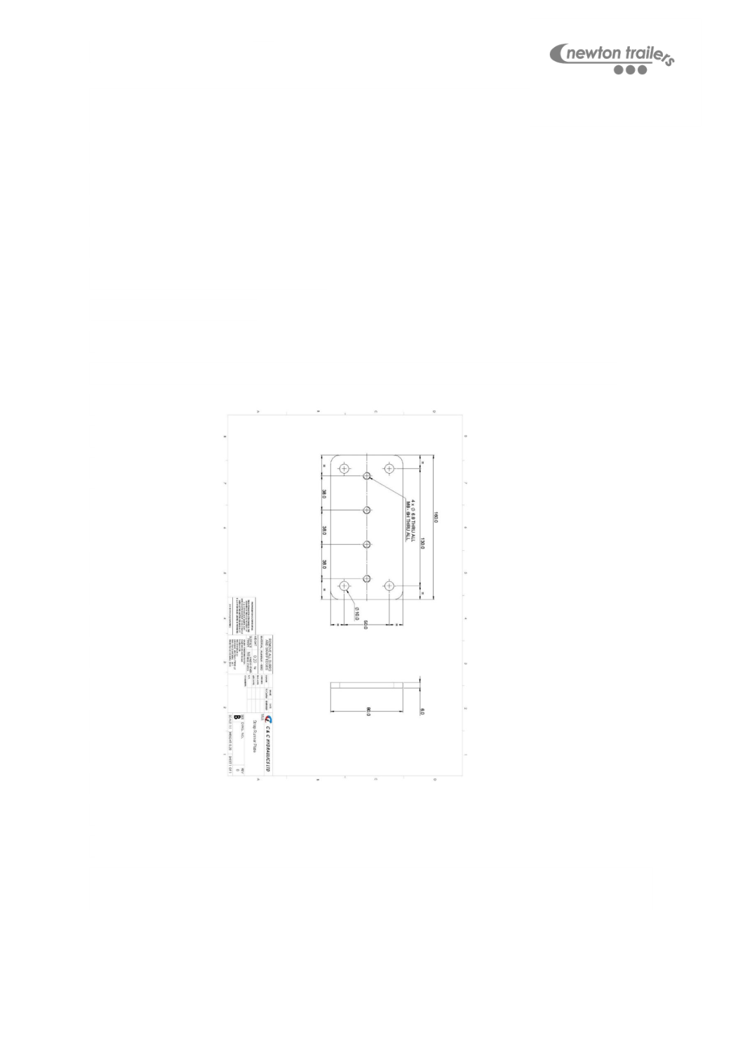
Step 8: Drill through the strap guide plate and outer skin of the body
appropriate hole for the strap guide position using an M8 drill tap.
For example,
1st intermediate – drill tap top 2 holes.
Middle – top 3 holes.
2nd intermediate - middle two holes.
Rear – Bottom two holes.
This is so that the straps run in line and is more aesthetically pleasing on the eye.
Step 9: Mount the Strap guides to the strap guide plates using M8x70 with locking nuts
(torque to fastener manufacturers spec).
Newton Trailers Limited

Wear Plates
Step 1: If dome wear strips are to be ﬁtted, lay out the nylon strips on the domes and
drill 5mm holes through the nylon and the dome, equal spacing 300mm apart length
ways and across the width. Fasten using 4.8mm large ﬂange rivets.
Front dome
The orientation of the plates must be noted, the side of the plate with 5 holes ﬁxes to the
body, the bottom of the plate should be ﬂush with the bottom of the top rail proﬁle.
Offer up the wear plate as above and mark the line to be folded.
Attach the plate with 4.8mm large ﬂange rivets on the side and 6.8 mono bolts on the
top.
Rear dome
Repeat the process as above.
Centre hoop position
When the double hoop is ﬁtted (as in the picture above) the process is repeated as with
the front & rear wear plates. Apart from the horizontal plane. Fix using 6.8mm mono-
bolts and shape the wear plate around the hoops with a hammer to eliminate and
contact with the sheet.
NOTE: To reduce any contact between the sheet and centre hoops on the nearside a
HC-WEARSTRIP may be required, this can be fastened into the centre hoops using
4.8mm large ﬂange rivets.
Newton Trailers Limited
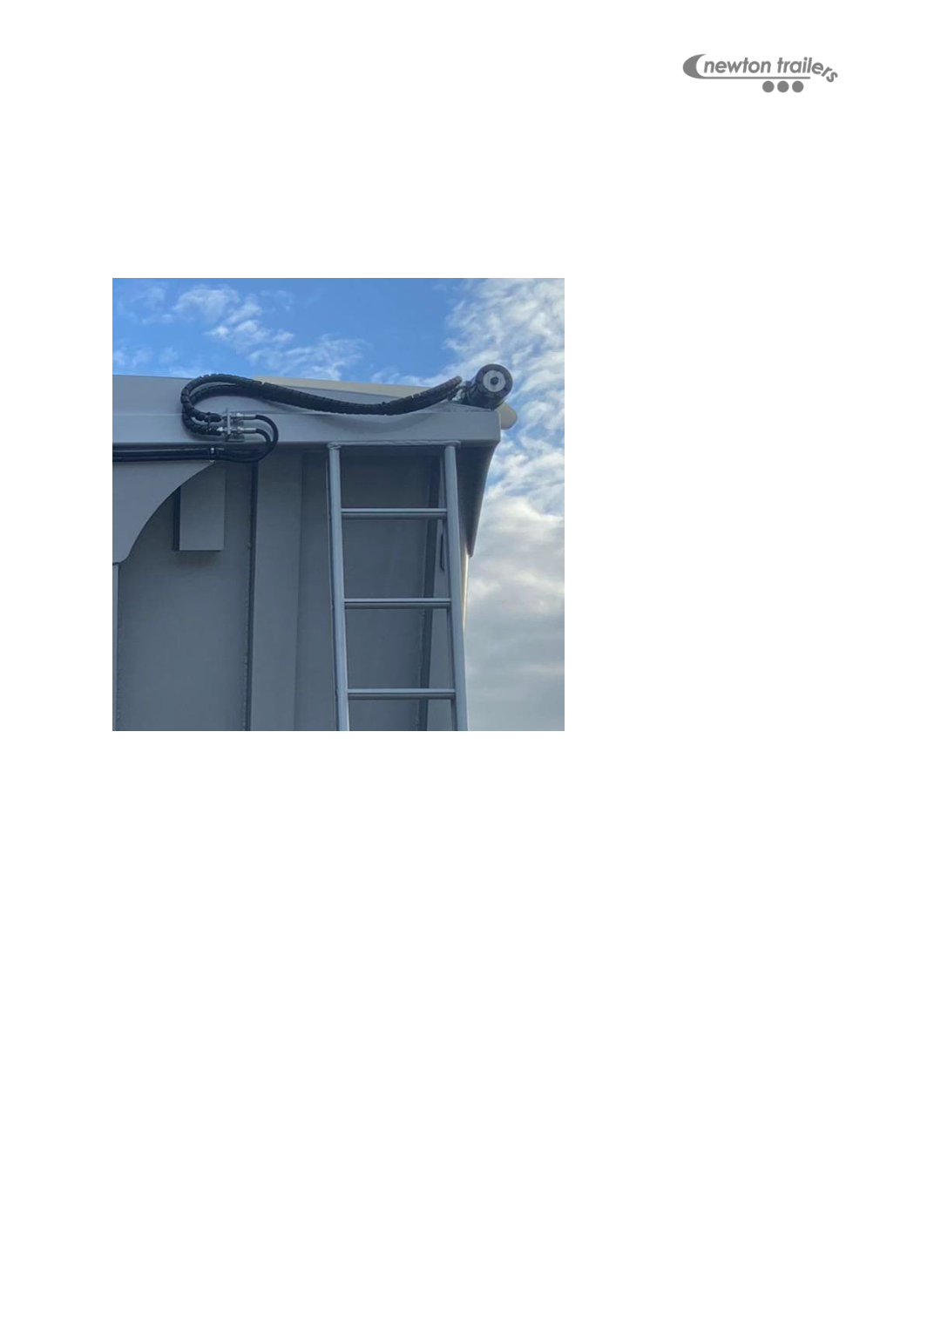
Hose Position
Step 1: Fit the HC-THB 600mm from the left-hand side of the trailer below the dome,
using the hose bracket as a template mark and using the M8 drill tap, tap the two
mounting hose and ﬁx using M8x16 bolts (torque to fastener manufacturers spec).
Step 2: Fit ¼” bulkhead
ﬁttings with nuts for the pipes
to attach.
Step 3: Fit the hoses from the kit (variable length) from the right-hand side pressure port
on the powerpack box, to the top hose bracket. From the top port on the box to top of
the bracket. From the bottom port on the box, to bottom on the bracket, leaving the
hoses loose on the hose tails for free movement with securing.
Step 4: Secure one hose with a 16mm hose clip using 4.8mm self-drilling Torx screws,
equal spacing. Cable tie the remaining hose to the ﬁxed hose and trim ﬂush with a
Stanley knife.
Newton Trailers Limited
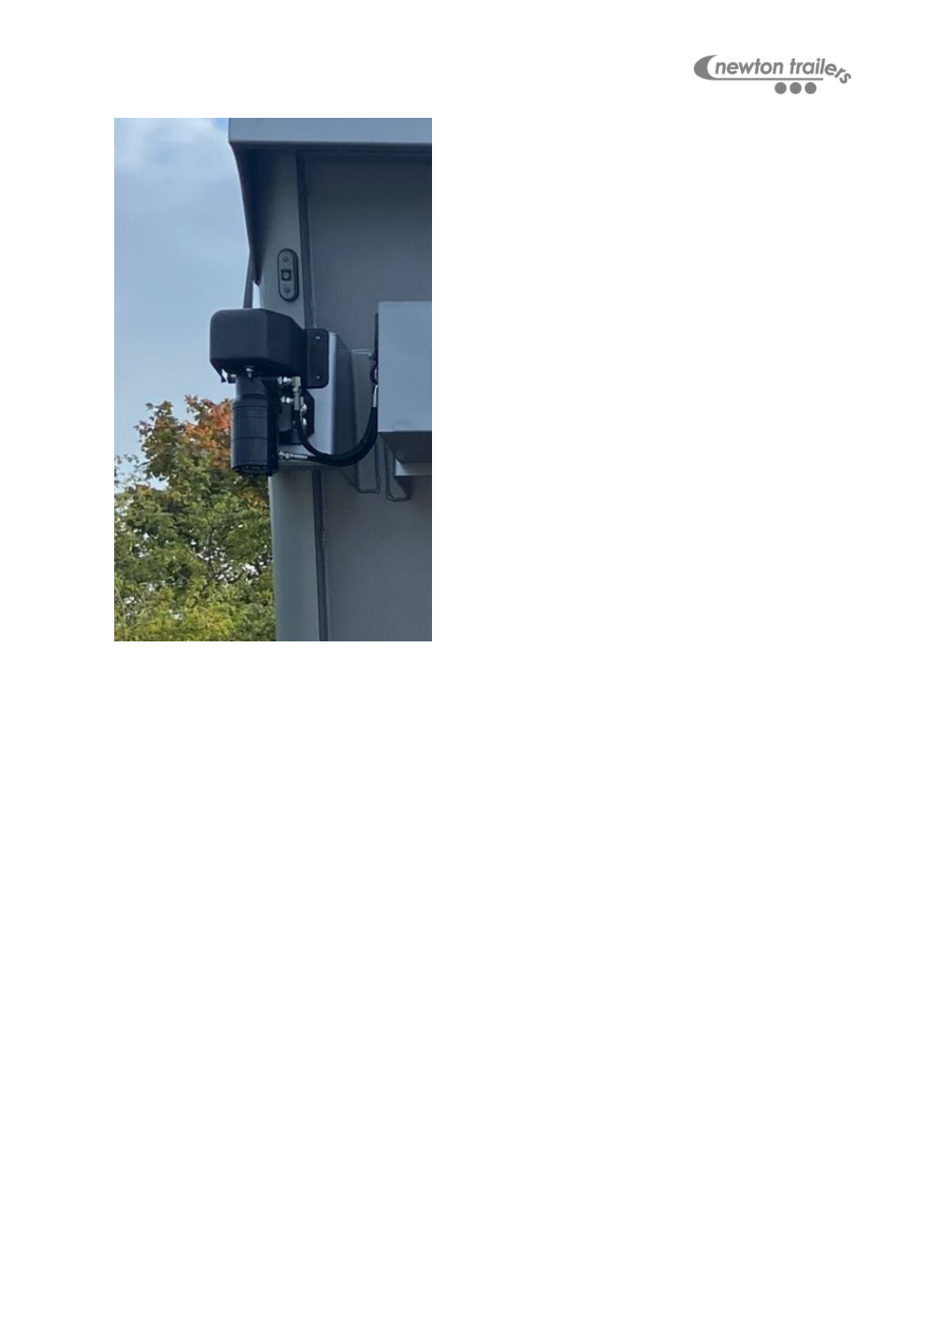
Step 5: Fit the hoses for the ZBMR brake motor. On the left-hand side of the box. Top
port to middle on the brake motor, Middle port on the box to top on the brake motor,
bottom port on the box to the bottom port on the brake motor (use hose adaptors if
required).
Note: Check and tighten all hose ﬁttings, double check preassembled components.
Adaptors required:
½” x ¼” M/M x2
¼” x ¼” M/M x1
½” bonded washer x2
Remove the upper blanking plug on the bottom of the motor (H6) and re use the ¼”
bonded seal for the pilot line.
Newton Trailers Limited

Wiring
Step 1: Mount the HC-TSP, Using the toggle switch plate as
a template mark the two mounting hole and drill using the
M8 drill tap. Fix using M8x16 stainless steel fasteners
(torque to fastener manufacturers spec).
Step 2: Mount the toggle switch, run the manual over-ride switch cable through the
toggle switch plate and bolt using M5x25 machine screws and locking nuts (torque to
fastener manufacturers spec). Run the cable up into the powerpack box and plug into
the PCB board of the sheet remote kit, leave the excess cable hanging loose for step 9.
Step 3: Run the battery cable through the conduit.
Step 4: Starting from your Anderson plug mounting position run the cable the length of
the chassis and up the body in line with the cable entry hole in the bottom of the
powerpack box. Secure the Anderson lead to the chassis loom using 7.6mm cable ties
and run up the body bridging the cross member free from any pinch points, secure with
30mm p-clips (torque to fastener manufacturers spec).
Step 5: Mount the HC-APP, using the Anderson plug plate as a template mark the holes
in the required position and drill to 6mm, Fix using M6x25 bolts and locking nuts (torque
to fastener manufacturers spec).
Step 6: On the Anderson plug end strip the cable back 20mm and solder on the
connection pins, heat shrink over the female side of the connector pin onto the cable to
prevent water ingress.
Step 7: Push the pins into the Anderson plug and mount to the Anderson plug mounting
plate using M6x40 bolts and locking nuts (torque to fastener manufacturers spec).
Step 8: Fasten the Anderson lead up the front bulkhead using 30mm P-clips and (torque
to fastener manufacturers spec).
Newton Trailers Limited
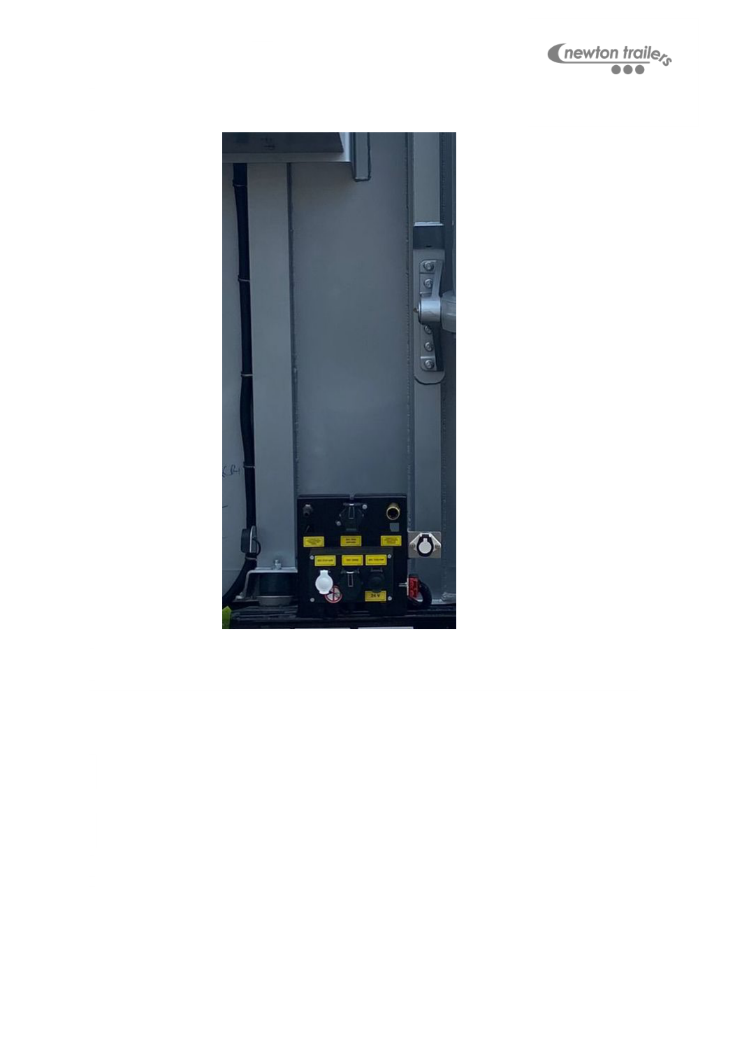
Step 9: Secure the manual over-ride switch to the Anderson lead using 4.8mm cable
ties and cut ﬂush to prevent sharp edges.
Newton Trailers Limited
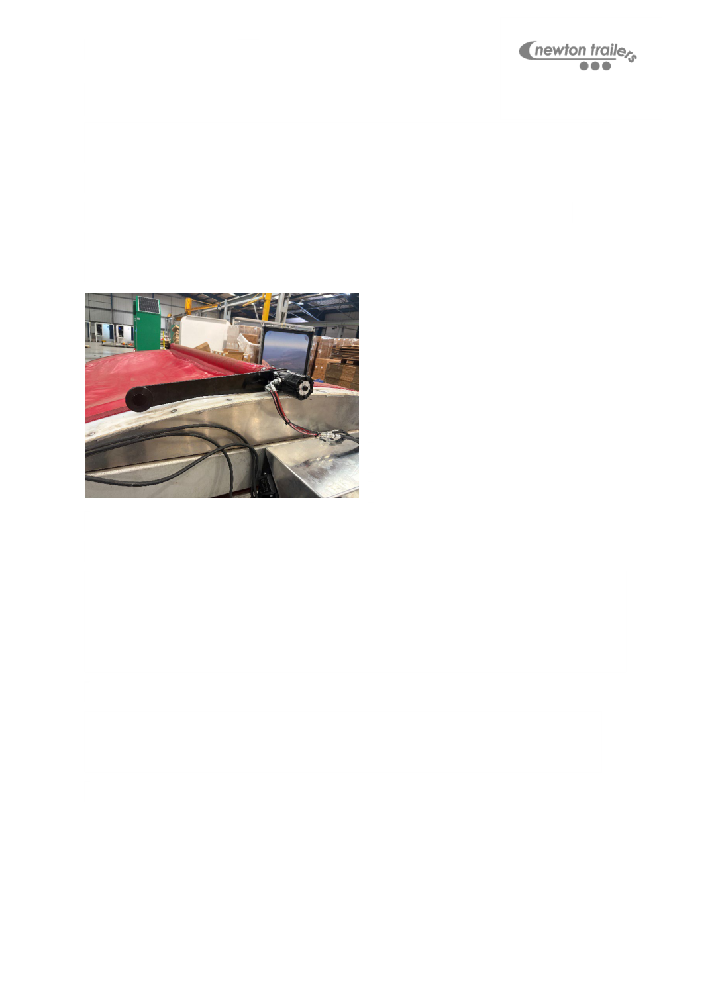
Centre Motor
Note: The ﬁtting of the top motor can be done if the sheet & poles are being ﬁt as new,
sheet ﬁtting manual is a separate document.
Roll the sheet all the way over to the closed position to carry out the next steps.
Step 1: Fitting the top motor assembly,
start by inserting the nylon sleeve into the
centre sheet pole, Insert the remainder of
the assembly into the nylon sleeve
leaving the tarp tube drive sticking out of
the nylon sleeve by approx. 5mm.
Step 2: (Option A) Using a 10mm bolt and a pair of mole grips clamped on the bolt head
heat up the bolt thread until glowing and burn through the sheet reinforcement webbing
in 3 positions (see picture below), Using those 3 positions as reference drill-tap to
10mm through the pole and tarp tube drive. Fix using M10x30 button hex bolts & repair
washers (torque to fastener manufacturers spec).
Step 3: (Option B) Using an 8mm bolt repeat the process above but drill through the
pole and tarp tube drive to 6.8mm and ﬁx using 6.8x25mm Mono-bolts and repair
washers.
Newton Trailers Limited
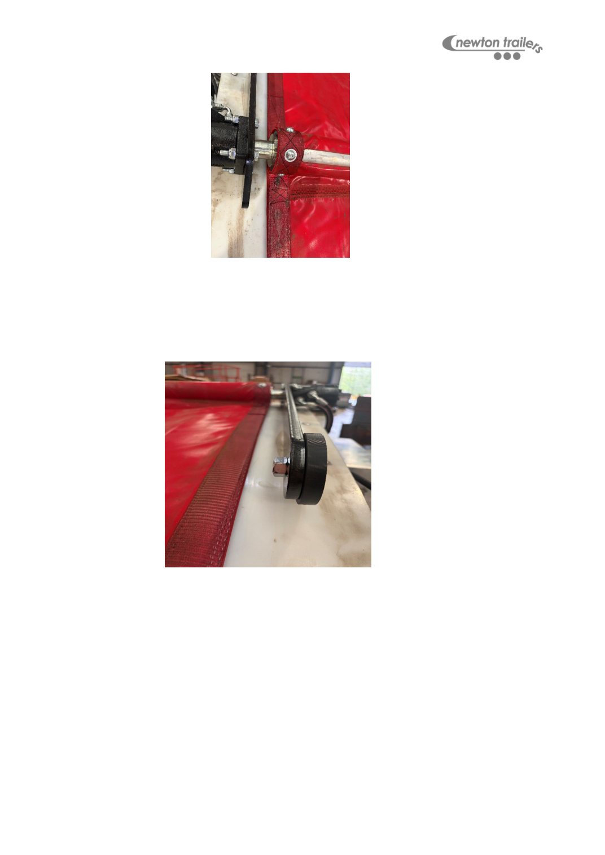
Step 4: If required trim the nylon roller axle ﬂush with the nut. Depending on the sheet
ﬁtting, the nylon roller axle may need to be cut ﬂush with the nut to prevent contact with
the side pole when the sheet is in operation.
Step 6: Fit the top motor hoses to the motor and HC-THB bracket, Top port on the
bracket to top port on the motor and bottom to bottom port.
Adaptors required:
½” x ¼” M/M x2
½” bonded seals x2
Newton Trailers Limited

Strap Fitting
Front position
Step 1: Offer up the strap to the side pole at 90 degrees, mark the pocket to be cut
before cutting out with a Stanley knife. If pole rollers are to be ﬁt, elongate the pocket to
be cut out.
Step 2: If a pole roller is to be ﬁt slide the side sheet pole to the rear, insert the pole
roller into the pocket and slide the pole back making sure the pole roller slides freely
over the side pole.
Step 3: Using the blow torch, burn off any loose stitching post pocket cutting.
Middle position
Repeat step 1 as above, pole rollers are not ﬁtted to the middle of the trailer.
Rear position
Repeat step 1 as the front position and step 2 if a pole roller is to be ﬁtted.
Pole roller fastening
If pole rollers are to be ﬁtted, follow the next step.
Mark either side of the pole roller, ensuring the roller runs across the domes. Using the
M8 drill-tap drill, drill through to the centre of the pole and fasten using M8x16 button
headed bolts (torque to fastener manufacturers spec).
Repeat for the rear pole roller.
HC-SIDE POLE CLAMP
Sold separately

Newton Trailers Limited

Pole rollers are ﬁt to reduce the side pole encountering the body, wh
roller is ﬁt to the side pole, the sheet strap encounters the side of th
increasing wear on both the sheet and strap. The most common place a sheet strap
breaks is on the rear of the pole when the strap is clamped.
When the pole rollers are coupled with the alu torque arm with roller this reduces wear
on the sheet and straps and removes the need for the nylon dome wear strips HC-DWS.
Bolting the straps to the pulley
Step 1: Thread the 5.05m front strap from the SK-TIP2STRAP kit through the ﬁrst strap
guide.
Step 2: Apply Vaseline to the threads of the strap retaining bolt.
Step 3: Insert the eye of the short strap into the top recess of the pulley and slide in the
M6x90 Cap head bolt to retain the front strap,
Step 4: Thread the longer split section of the SK-TIP2STRAP kit through the strap guides
from the front. The shorter stitched section feed in the top port of the middle strap guide
and the longer section through the bottom port and onto the rear.
Step 5: Insert the eye of the longer strap into the bottom recess of the pulley and thread
the bolt through the strap eye and into the thread of the pulley, tighten ﬁnger tight only.
This makes future strap replacement easier.
Note: It is important to make sure all straps are not twisted or tangled.
Step 6: Wrap the straps around the pulley anticlockwise so that when the strap is
unwinding it runs clockwise and releases from the spool to the outside of the body.
Wind the straps up until the stitched section of the middle and rear strap is just about to
enter the front strap guide. Pull the straps tight on the pulley and repeat.
Newton Trailers Limited

Step 7: Spray the ZBMR brake motor shaft with copper grease or us
Fit the pulley to the ZBMR brake motor and fasten with an M8x50 bol
ﬂat washer, tighten using a hand ratchet and nip the bolt.
Note: Do not over tighten as this will make strap replacement and splitting the pulley
from the motor easier.
Fitting the pulley cover
Step 1: Mark two holes on the mounting ﬂange of the pulley cover.
A: If pulley cover is plastic offer up over the pulley and drill the marked holes with a
4mm drill bit, Fix using 4.8 x 25mm dome headed torx self-drilling screws to prevent the
plastic from splitting (torque to fastener manufacturers spec).
B: If pulley cover is Aluminium then drill the marked holes to 10mm using a10mm drill
bit, Mark the ﬁxing holes on the Aluminium brake motor body bracket using an 8mm
drill-tap. Fix using M8x16mm dome headed hex bolts and washers (torque to fastener
manufacturers spec).
Note: Make sure the pulley cover does not encounter the pully or straps when mounted.
Newton Trailers Limited

Strap clamping
Step 1: Wrap the strap around the pole from the rear and ﬁt the strap clamp with the
studs facing away from the body as in the above image. Pull the strap tight and ﬁt the
ﬁrst clamp plate, run the strap back up over the outer side of the plate and ﬁt another
plate over the top and ﬁt the locking nuts (torque to fastener manufacturers spec).
Never over tighten as the studs can spin where they are spot welded to the rear plate
and the threads can strip; it is recommended that a hand ratchet be used for these.
Step 2: Cut the strap to length, burn of the end to prevent fraying.
Step 3: Cable tie the cut off end to the bottom side of the strap clamp and cut the tail of
the cable tie ﬂush.
Repeat for all steps for all 3 strap positions.
Newton Trailers Limited

Storm straps
Note: If storm straps are not required skip this section.
Fitting the storm strap eye
Step 1: Mark the desired position on the side pole for a pocket to be cut for the HC-
STORMSTRAPEYE (bearing in mind the side wall construction). Cut the sheet and burn
off and threads remaining.
Step 2: Wrap the storm strap eye around the pole from the rear so the eye is hanging
away from the body, temporarily secure the storm strap eye in position with duct tape.
Step 3: heat up a 10mm bolt with the blow torch until glowing and burn a hole through
the strap either on the underside of the pole or outer edge.
Step 4: Once the molten webbing has cooled, drill tap an 8mm hole through to the
centre of the pole and secure using an M8x30 button headed bolt & repair washer
(torque to fastener manufacturers spec).
Note: Alternatively, this can be drilled to 6.8mm and a mono-bolt with washer can be
used.
Newton Trailers Limited

Fitting the storm strap anchor
Step 1: Offer the storm strap anchor 100mm below the storm strap eye (bearing in mind
the side wall construction).
Step 2: Drill through the body with a 10mm drill bit using M10x50 bolts with locking
nuts, repair washers or a backing plate may be required to prevent crushing, (torque to
fastener manufacturers spec).
Step 3: Hang the storm strap from the anchor to line up for the HC-SSG ﬁtting. Place the
storm strap guide on the bottom rail of the body, mark the mounting holes and drill to
5mm, ﬁx using 4.8mm rivets.
Fixing the storm strap ratchet
Step 1: Finding the desired position for the HC-SSR, position the storm strap ratchet in
the desired position and mark a hole to secure the ratchet. Drill to either 8 or 10mm and
secure with bolts & locking nuts.
Note: If the ratchet is binding in the mounting position, pack out between the body and
the ratchet with washers or weld a cut section of 50x75mm Alu or Steel box section.
Step 2: Cut the storm strap tail to length with a diagonal cut and burn off the tail to
prevent fraying.
Step 3: Lubricate the ratchet.
Note: Cutting the strap tail diagonally aids threading the strap into the ratchet.
Newton Trailers Limited

Securing the sheet poles
If the centre pole has been secure in the sheet ﬁtting section (separate manual) then
miss this next section.
Centre pole
Step 1: Using half round 25mm beading cut four pieces into 350mm lengths and lay out
on the top of the sheet pole, measurements are variable as long as its equal distances.
First position can be 100mm from the webbing strip sewn into the sheet, mirrored on
the rear then either side of the centre hoop for the middle.
Step 2: Drill x3 5mm holes in each strip 30mm in from each end one central, fasten
using 4.8 x 25mm large ﬂange rivets.
Step 3: Drill to 5mm and rivet the webbing strip at the rear of the centre sheet pole and
fasten with 4.8 x 25mm large ﬂange rivets.
Step 4: Fit RTI1164 sheet pole end cap if required.
RTI1164 – 88mm plastic insert – centre pole
Side pole
Step 1: Marking the ﬁxing points to secure the side pole in the pole pocket. Mark a point
on the front sheet webbing strip, either side of the sheet strap pocket, middle either side
of the strap pocket and rear either side of the strap pocket.
Step 2: Drill holes to 5mm and ﬁx using 4.8mm x 25 large ﬂange rivets.
Step 3: Fit RTI455 side pole end caps if required.
Note: Side pole end caps can be sold separately to close off the open ends of the sheet
pole.
RTI455 – 50mm plastic insert – side pole
Newton Trailers Limited

Final system checks
Step 1: Fill the sheet pack with oil.
Note: It is recommended that ATF ﬂuid be used to prevent bacterial growth clogging up
the tank suction ﬁlter.
Step 2: Check all hydraulic ﬁttings are tight with a spanner to prevent any oil leakage.
Step 3: Turn on the Icarus remote set and check power status, Pairing the remote
system to the Icarus app can run ﬁrmware updates and check for any electrical issues.
Step 4: Check all persons are clear of the sheet before operating.
Step 5: Operate the sheeting system open and closed 4 or 5 times.
Step 6: Check for oil leaks.
Step 7: Top up oil if required.
Step 8: Check sheet straps for tightness and adjust if required.
Note: It is important that the oil level and all ﬁxing and hoses be checked 1 week after
system ﬁtting and that the sheeting system must be inspected upon the date over every
vehicle inspection.
Max sheet pack operating pressure 150 Bar when sheet hits the sheet stops or the limit
when closing.
Optimum pressure with Aluminium torque arm and side pole rollers the sheet system
pressure runs at 50 bar, when the sheet hits the apex of the dome the pressure will spike
to 90 Bar.
ZBMR brake pilot pressure to release 25 BAR.
Never:
Under any circumstance must the pressure relief valve be adjusted, this is preset at 150
Bar, Increasing the pressure relief can burst motor seals, split the roof sheet and pull
the sheet strap clamps loose.
Newton Trailers Limited

Trouble shooting
• If the Icarus remote turns on but does not pair, Check the status light on the
receiver.
• No status light on the receiver? Check power to the sheet pack starter using a
test lamp or multi meter.
• No power to starter motor? Check Anderson plug connections and power supply
form source.
• Icarus remote paired to receiver but no output action? Pair the receiver to the
Icarus app and check error codes and ﬁx.
• No error codes from the Icarus system? Check output from the starter motor and
replace if needed.
• Starter motor working but no movement in hydraulic system? Check pressure
output on the pressure gauge.
• No pressure at the gauge? Check oil level.
• Starter motor working and pump starting no output? Check power to coils & test
coils.
• Sheet motor struggling to open/close sheet? This indicates a weak motor.
Fit adaptor pressure gauge adaptor in pressure lines and check pressures to
motors. Check the ZBMR pilot line for pressure to release the brake (refer to
system checks for pressures).

Icarus operating and troubleshooting manual comes with the remote set, further
digital copies available upon request.
Newton Trailers Limited
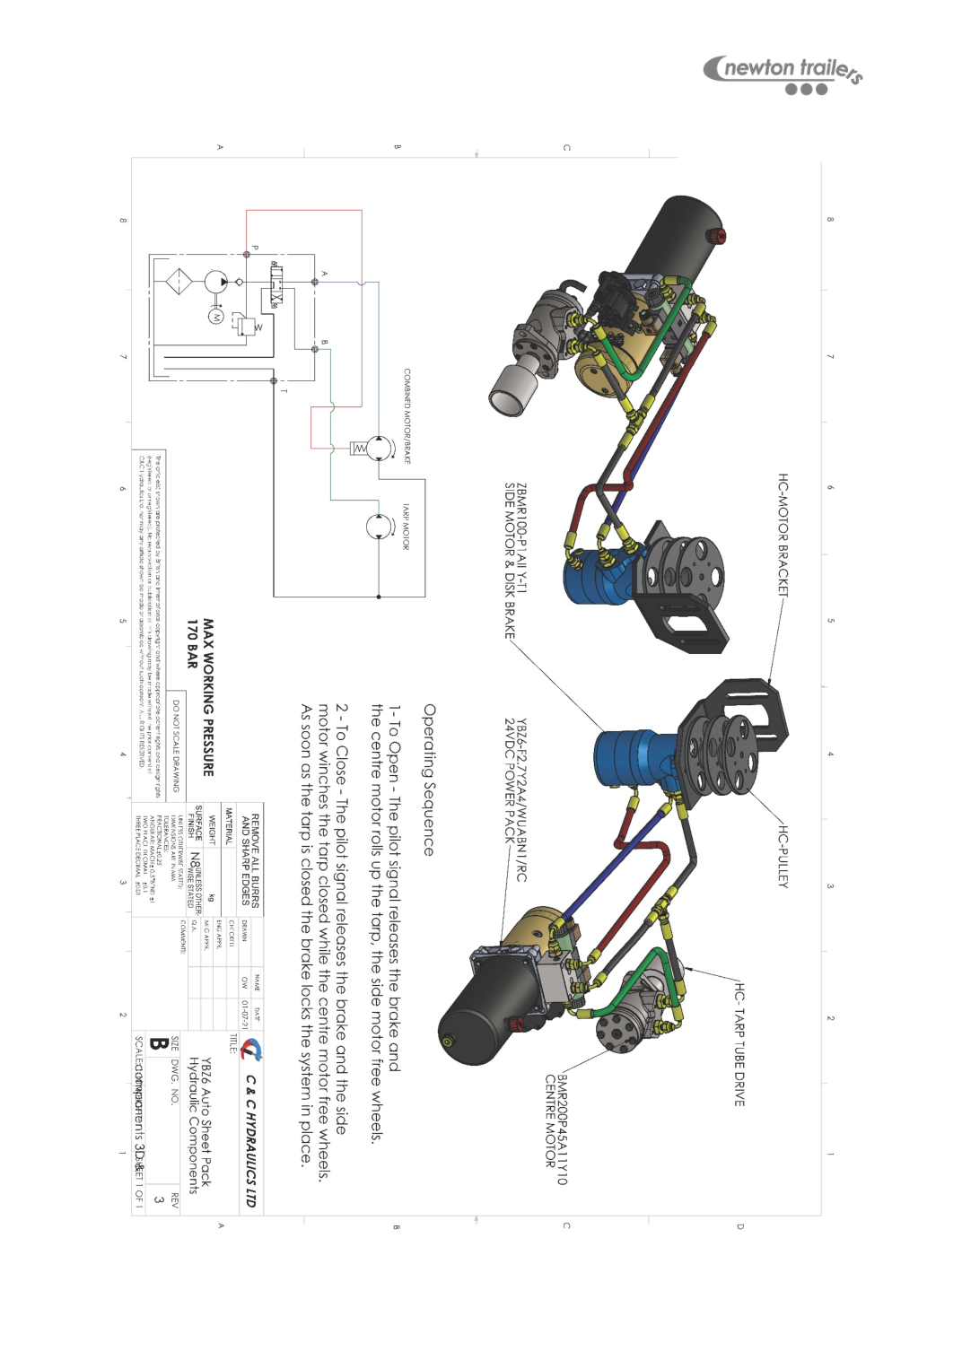
Newton Trailers Limited
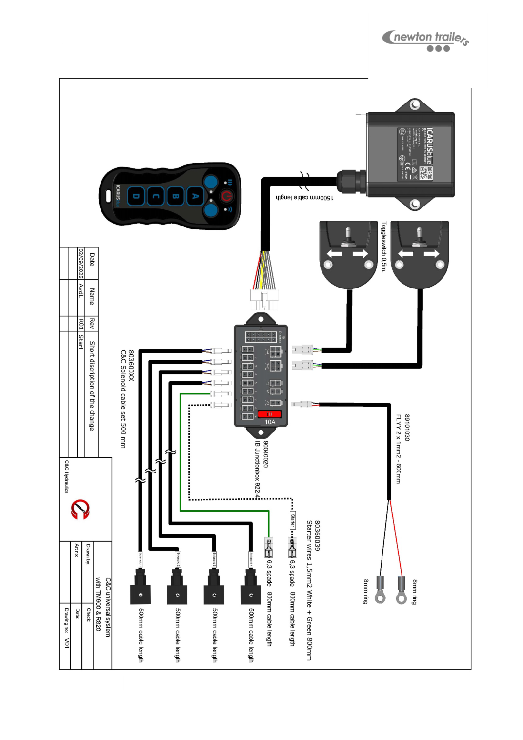
Newton Trailers Limited
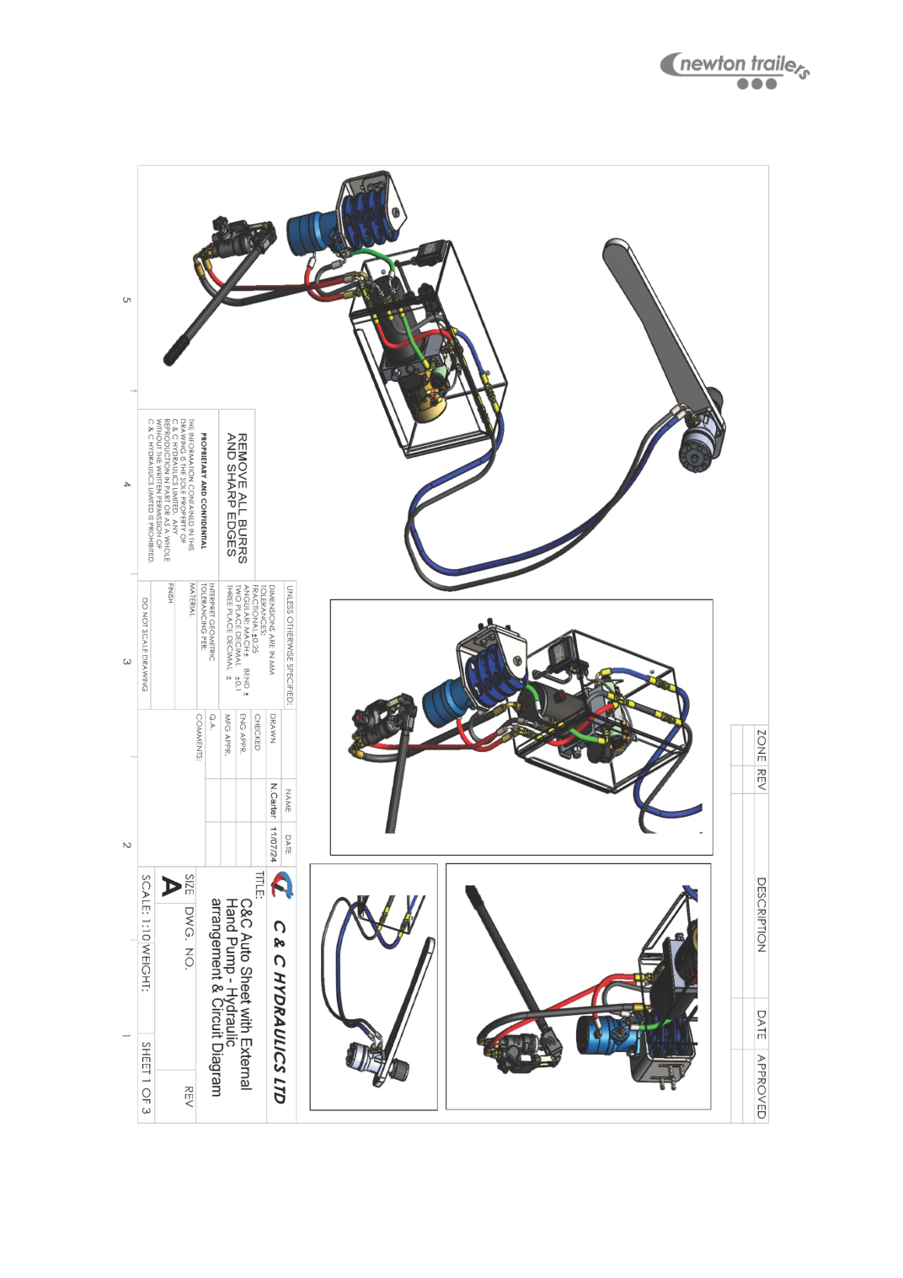
Newton Trailers Limited
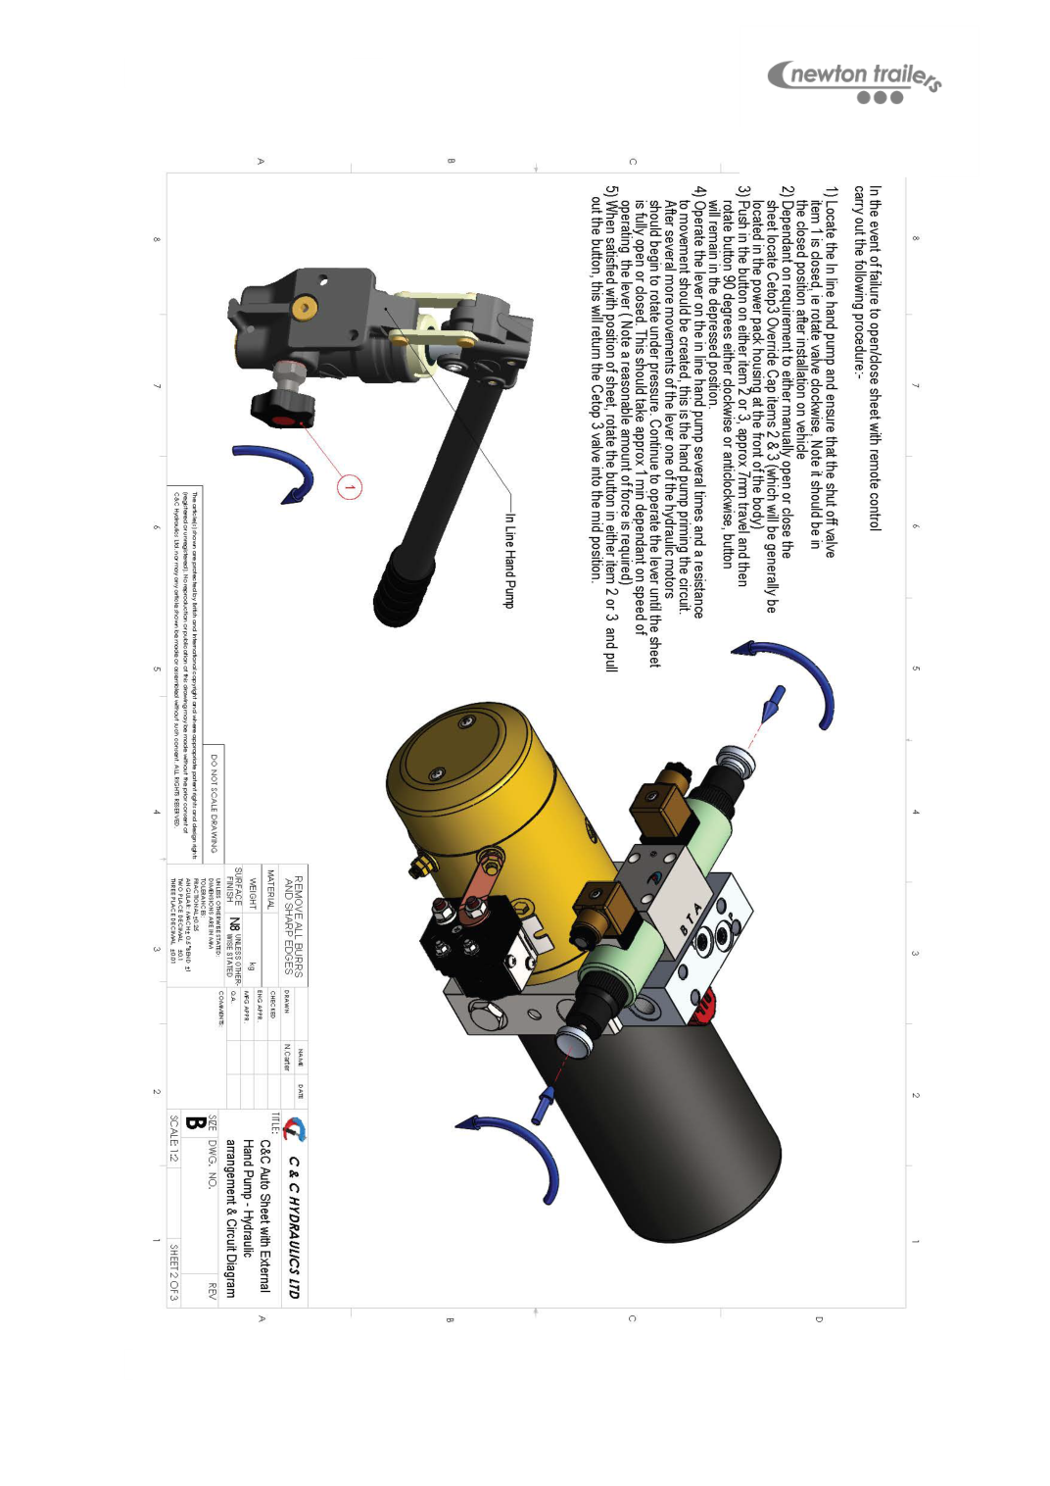
Newton Trailers Limited

Newton Trailers Limited
Newton Trailers Limited
Station Yard, Station Road
Ridgmont, Bedfordshire
MK43 0XP
01525 872466
sales@newtontrailers.com

